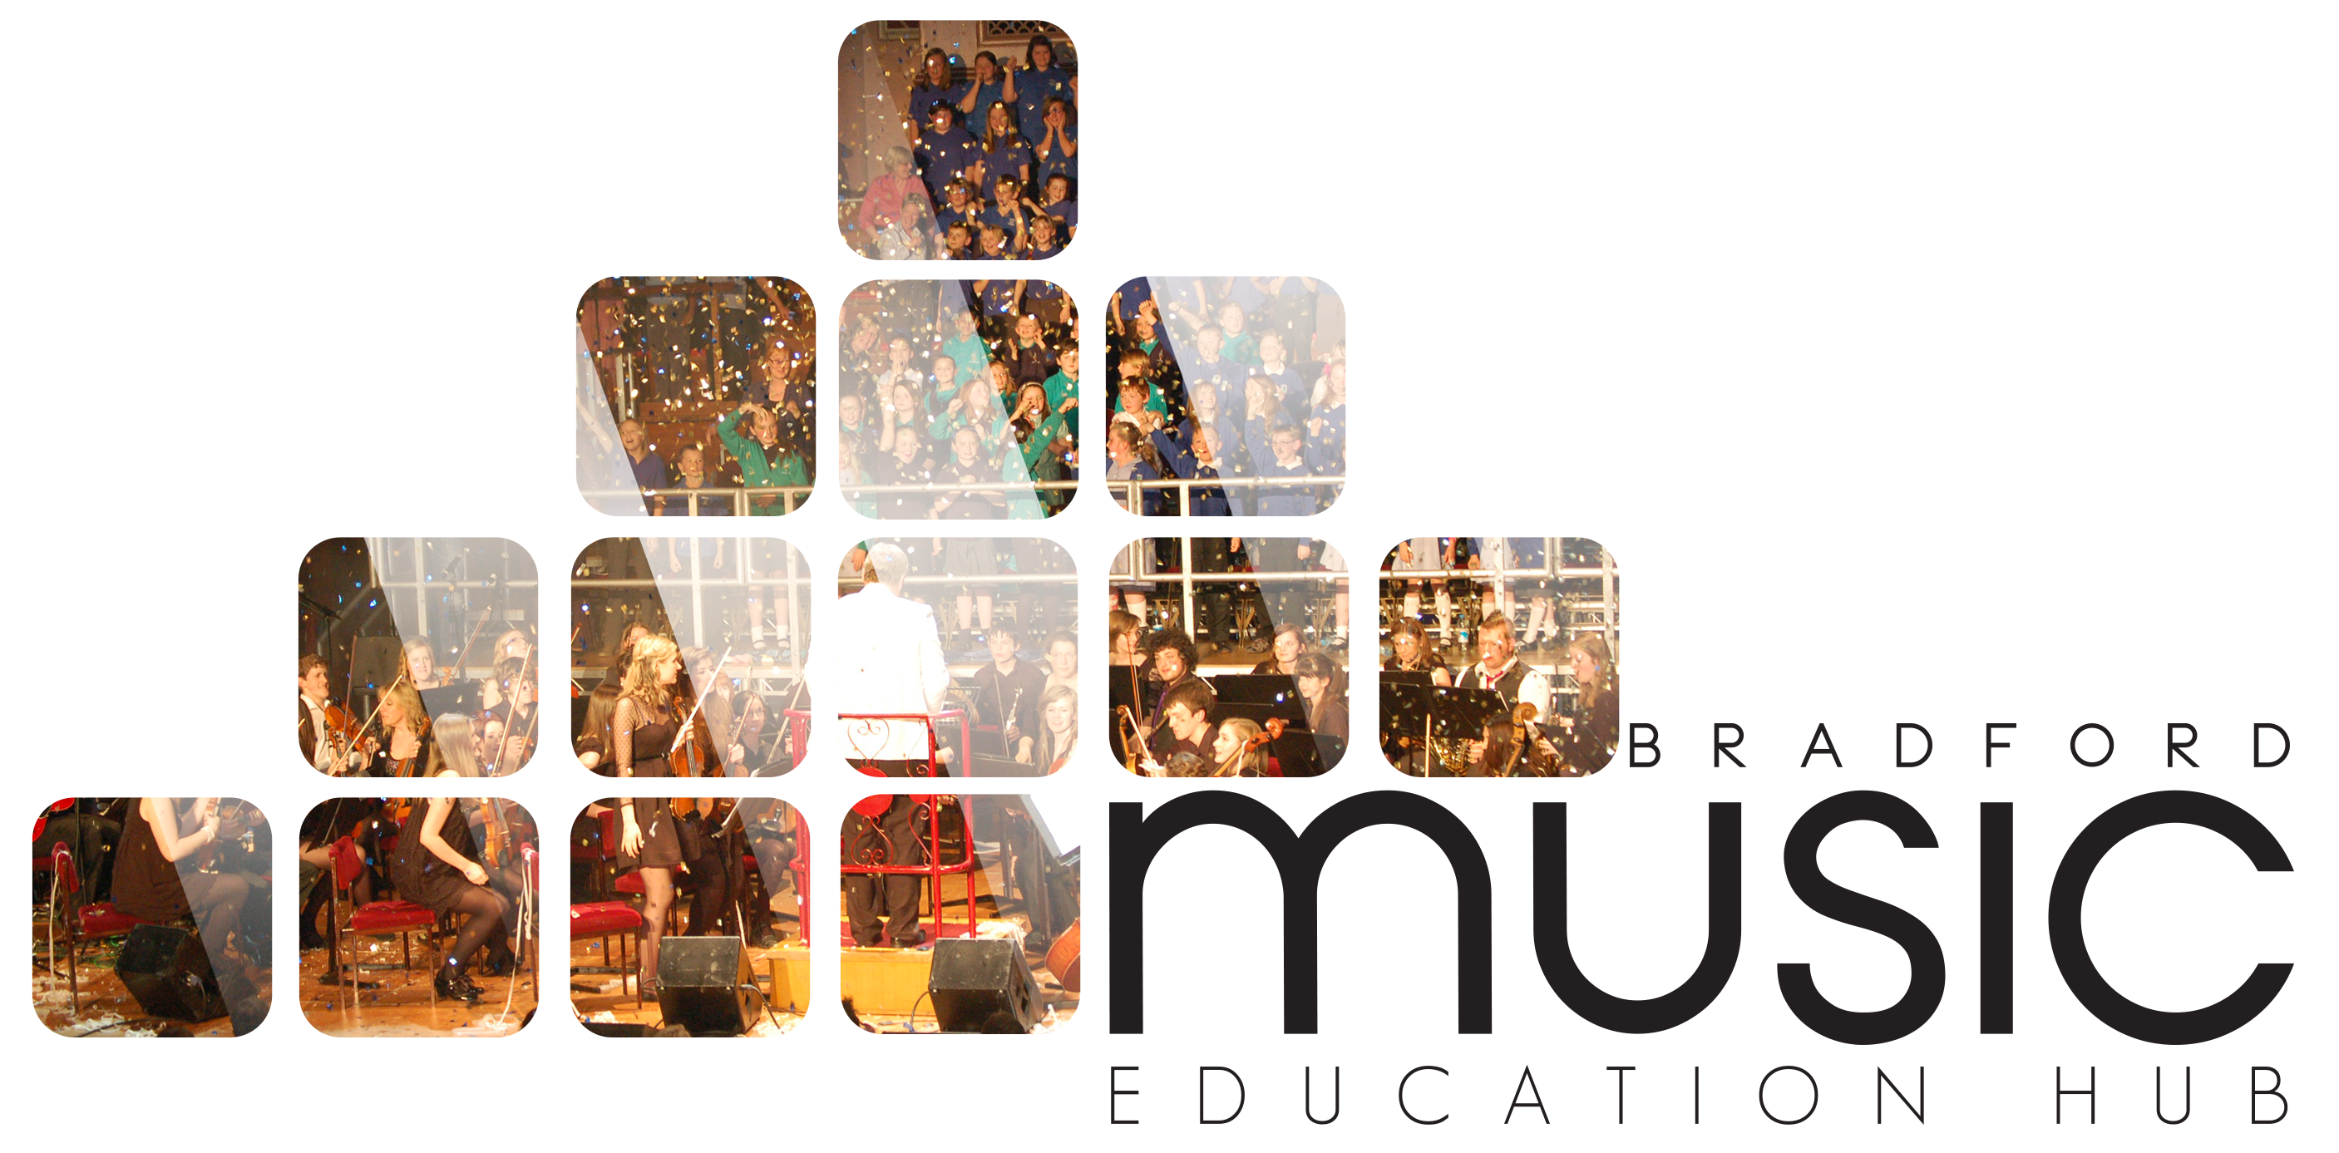

Music & Arts Service Future House, Bolling Road, Bradford, BD4 7EB
Tel: 01274 385554 Fax: 01274 385588

BBC MUSIC DAY

FRIDAY 5 JUNE 2015

How to get your school involved

BBC Music Day will connect communities and generations with an inspirational celebration of music across the UK. This inaugural, nationwide initiative takes place on Friday June 5th 2015.

In a celebration of the musical passion and creativity of the UK, there will be large scale musical events as well as locally-organised activities; intergenerational singing and a wealth of musical innovation from classical to pop.

Coverage is planned across the whole day via Local and Network BBC TV & Radio, culminating in BBC Music Night. Live from Glasgow, the BBC Scottish Symphony Orchestra will be joined by special guests across musical genres and broadcast simultaneously on BBC Radio 2 and BBC Radio 3.

With support from ambassadors and organisations including Music Education Hubs, music charities and local councils, BBC Music Day will become an annual fixture in the calendar, celebrating our diverse musical talent, forging new musical collaborations and inspiring new connections.
- This is your school’s chance to participate in the inaugural BBC Music Day we are looking for 1000+ children to perform Connect it – BBC’s Ten Pieces Body Percussion
- Joining in a massed community and school sing
The event itself is to take part in City Park, Bradford. The event starts at 1 pm with various school and community acts taking to the big stage. This will be followed by rehearsals of the massed body percussion and sing between 4 – 5 pm. Between 5 – 8 pm the main BBC event starts featuring these two performances as well as performers from BBC Introducing! - lots of up and coming bands/groups.

WHAT COMMITMENT IS REQUIRED FROM MY SCHOOL?

- Sign up to say you wish to participate – we need large numbers from each school to take part as training and resources will be provided for the body percussion

- A trainer will be provided to the school to train staff and pupils on the body percussion in small groups

- Resources will be placed online for the massed community and school sing and some vocal training

- Ensure all pupils and parents are on board as this will mean participation out of school hours

- Schools are responsible for their own pupils at all times

- Pupils need to be available between 4 – 7 pm as a minimum

- Possible broadcast on BBC TV and we are expecting coverage from news stations and newspapers so ensure you have the right permission in place for pupils to participate
MAKE IT A FULL AFTERNOON

Your school is also invited to come down to City Park from 1 pm as live music will be taking place and you will be able to use the BBC Experience Tent.

Bring lunch and enjoy entertainment from 1 pm – live bands/orchestras will be performing and the BBC Experience Tent is available to use.

The BBC Experience is a pop-up stand that is touring the country and giving audiences across the regions the opportunity to interact with BBC content and services.

Come along and try your hand at reading the news and presenting the weather, making a radio drama and commentating on a sports match. Activities for visitors will also include a demonstration by the BBC Blue Room which showcases all the different ways that audiences can access the BBC, a chance to meet some of our CBeebies characters and an opportunity to come away with a photograph of Doctor Who.

This is a free event and families are welcome to come along as audience at any point during the day/evening. The event will be running alongside the first day of the World Curry Festival and should prove to be a vibrant and cultural experience for your pupils and families.

Please return the reply slip by 24 April 2015 in order that the body percussion training can be scheduled with your school.

