Music & Arts Service Future House, Bolling Road, Bradford, BD4 7EB
Tel: 01274 385554 Fax: 01274 385588

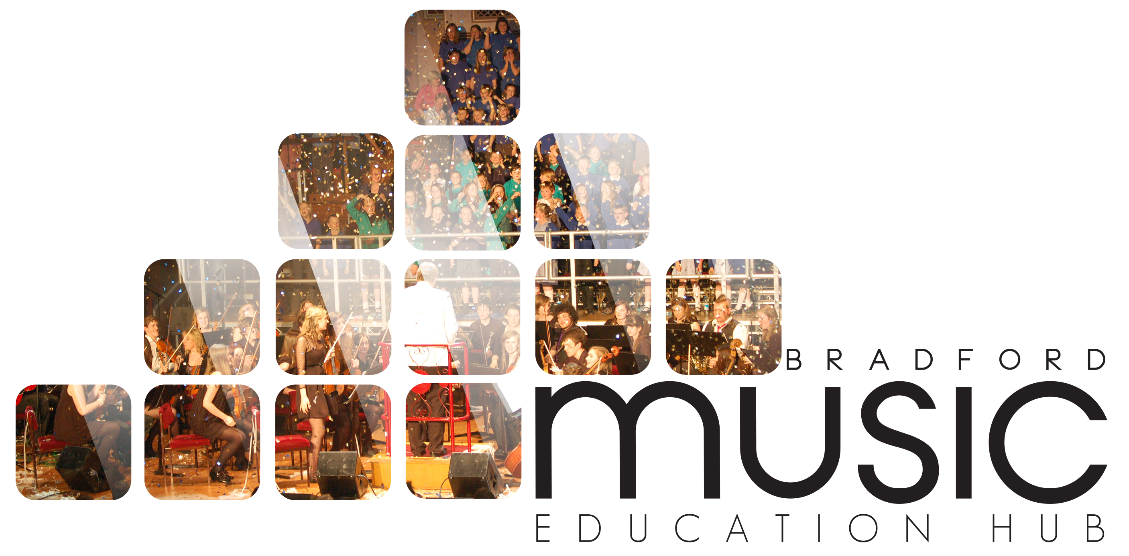

BBC MUSIC DAY

FRIDAY 5 JUNE 2015

REPLY SLIP

School Name: _______________________________________________________________________
School Contact Name: ________________________________________________________________
School Contact Email: ________________________________________________________________
School Contact Tel No: ________________________________________________________________

We would like to bring ________ pupils for the Body Percussion and Massed Sing

Undertaking from school:

We will make time available for training on body percussion
We will rehearse the songs which will be placed online
We will be available for rehearsals between 4 – 5 pm
We will be available for the main event between 5 – 7 pm

Signed: _______________________________________________ Date__________________________

Name:__________________________________________ Position in school:________________________

