Our ref:  Your ref: | Department of Children’s Services  – Aiming High for Children  Music & Arts Service  Fairfax Learning & Development Centre,  Flockton Road, Bradford, BD4 7RY  Tel: 01274 434 970  Fax: 01274 408 335  Email: schoolsmusicandarts@bradford.gov.uk  Website: www.bradfordmusiconline.co.uk
The Headteacher/
Music Co-ordinator or Head of Music
ALL BRADFORD MDC SCHOOLS
21 January 2019

Dear Headteacher/Music Co-ordinator or Head of Music

MUSIC DATA RETURN – ACADEMIC YEAR 2018-2019

Annually we are asked to collate information across the Bradford MDC to return to Arts Council, all information is then fed through to the DfE in order that a more accurate picture can be formed of music across the whole country.

We hope you will be able to support this information gathering exercise by providing information about pupils receiving musical opportunities in your school. Please find attached the data form which I would be grateful if you could complete as fully as possible.

Tab 1 – Whole Class Ensemble Teaching (WCET) – data is required for pupils taking part in both schemes taught by the Music & Arts Service, by school staff and by external providers contracted by the school.

Tab 2 – please provide this information if you as a school deliver or contract an outside agency. Any ensembles/groups which you have booked directly with the Music & Arts Service do NOT need including as we already hold this information.

Would you also complete the small group/individual pupil level information, if known, for your pupils including those who play but may not be in one of your ensembles. (this is needed for your pupils only taught by yourselves or external providers NOT Music & Arts Service staff).

Just a reminder that the information is required for this academic year.

In the unlikely event it is a “nil” return for your school please indicate this also on the form so that we can show the reason in our records.

All pupil data is anonymous when sent to Arts Council. The data provided to ourselves is used to track pupil progress and their musical pathways throughout their school life.

Please complete the data collection required NO LATER THAN FRIDAY, 8 MARCH for inclusion in the 2018-19 data collection for Bradford MDC.

If you currently do not have a whole class ensemble teaching (WCET) scheme and would like details of this scheme, which we can heavily subsidise, please contact Debbie Bellwood on 01274 435014 who will be happy to discuss options to suit your school.

Thank you for your assistance in this matter.

Yours sincerely

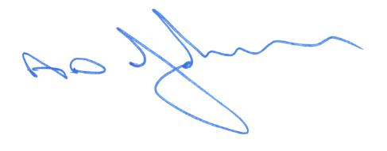

Tony Johnson
Head of Music & Arts Service

Enc

