Our ref:  Your ref: | Department of  Children’s Services  – Aiming High for Children  Music & Arts Service  Fairfax Learning & Development Centre, Flockton Road,  Bradford, BD4 7RY  Tel: 01274 434970  Fax: 01274 408335  Email: schoolsmusicandarts@bradford.gov.uk
Headteacher
Music Co-ordinator
Head of Music
8 September 2017

Dear Headteacher/Music Co-ordinator/Head of Music

MUSIC CURRICULUM AUDIT

Further to your first audit with yourselves, Ofsted has tasked all Music Education Hubs to visit schools and audit the delivery of music in the curriculum in all schools on an annual basis. We hope you will work with us to achieve this.

Music Auditors working with the Bradford Music Education Hub will be making arrangements to visit schools - their names are:

- Tony Johnson – Head of Music & Arts Service
- Felicity French Assistant Head of Music & Arts Service
- Carl White – Assistant Head of Music & Arts Service
- Helen Richmond – External Auditor

Please complete and return the audit form by clicking the hyperlink below. This is a tool to help you assess your school’s current position and to help with plans for the future. http://www.bradfordmusiconline.co.uk/site/ofsted-music-curriculum-audit/

NB: please ensure you click the correct link i.e. primary / secondary or special

“...music education hubs in every English local authority area are gearing up very adeptly to help schools develop their music teaching and curriculum. They are backed, in turn, by Arts Council England, DfE, Ofsted and the whole music education sector. There’s plenty of support and hubs can help you find it. Hubs receive some public funding and every school has a stake. So, school and academy leaders please let your hub in. Ofsted does expect this.”
Robin Hammerton HMI, Ofsted National Lead for Music” (Taken from the Ofsted blog 16.06.2014)

We hope that you will be able to work with us in order to provide the best possible musical experiences for our young people.

If you require an early visit or need some advice or information please telephone Debbie Bellwood on 01274 435014 and we will be happy to schedule an early meeting or put you in touch with the correct person to provide the information you require.

Letters for the new audit meetings will be scheduled from September 2017 onwards. This letter will detail the scheduled audit day/time together with a copy of the last audit submitted.

If we can be of any assistance in the interim please do not hesitate to get in touch with us.

Yours sincerely

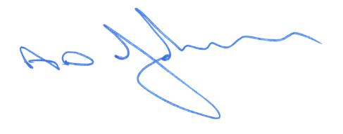

Tony Johnson,
Head of Music & Arts Service

