Our ref:  Your ref: | Department of  Children’s Services  – Aiming High for Children  Music & Arts Service  Fairfax Learning & Development Centre, Flockton Road,  Bradford, BD4 7RY  Tel: 01274 434970  Fax: 01274 408335  Email: schoolsmusicandarts@bradford.gov.uk
Headteacher
Music Co-ordinator
Head of Music
22 August 2018

Dear Headteacher/Music Co-ordinator/Head of Music

MUSIC AUDIT – CYCLE 3

Music Education Hubs are tasked to visit schools and audit music provision in all schools on an annual basis which has been valued by our schools over the last 2/3 years and we continue these audits into the academic year 2018-19. We hope you will work with us to achieve this.

Music Auditors working with the Bradford Music Education Hub will be making arrangements to visit schools - their names are:

- Tony Johnson – Head of Music & Arts Service
- Felicity French Assistant Head of Music & Arts Service
- Carl White – Assistant Head of Music & Arts Service
- Helen Richmond – External Auditor

Please complete and return the audit form by clicking the hyperlink below. This is a tool to help you assess your school’s current position and to help with plans for the future. http://www.bradfordmusiconline.co.uk/site/ofsted-music-curriculum-audit/

NB: please ensure you click the correct link i.e. primary / secondary or special

If you require an early visit or need some advice or information please telephone Debbie Bellwood on 01274 435014 and we will be happy to schedule an early meeting or put you in touch with the correct person to provide the information you require.

Letters for the new audit meetings will be scheduled from September 2018 onwards. This letter will detail the scheduled audit day/time and will be emailed out to the school.

If you require a copy of your previous audit sending out please let us know.

If we can be of any assistance in the interim please do not hesitate to get in touch with us.

Yours sincerely
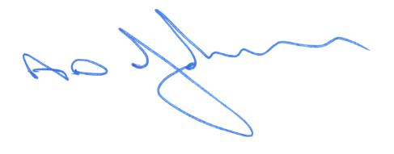
Tony Johnson
Head of Music & Arts Service

