Our ref: TIBTIU  Your ref: BBC Consent | Department of  Children’s Services  – Aiming High for Children  Music & Arts Service  Fairfax Learning & Development Centre,  Flockton Road, Bradford, BD4 7RY  Tel: 01274 434 970  Fax: 01274 408 335  Email: schoolsmusicandarts@bradford.gov.uk
The Headteacher/
Member of Staff responsible for pupils
Attending This is Bradford – This is Us!
7 June 2019

8 May 2019

Dear Headteacher

THIS IS BRADFORD – THIS IS US! – BBC MUSIC DAY LAUNCH – 7 JUNE 2019

As the BBC are now using this day to launch BBC Music Day for 2019 it is necessary to ask participating schools to sign up to their media terms and conditions.

These are set out as follows:

- You confirm that you are the Child’s parent or legal guardian or adult acting in loco parentis.
- You agree to the recording and/or broadcasting of Your Child’s Contribution and assign to the BBC all rights in Child’s Contribution for the BBC to use it worldwide in perpetuity in all media known now or in the future.
- Although the BBC hopes to use Your Child’s Contribution, it cannot guarantee to do so.
- If you agree with these terms please sign below. If you are unsure of the meaning of any of the terms set out above please contact your BBC Music Day event coordinator who will then liaise with the BBC Contact.

In order to simplify matters please could you sign and return this letter in its entirety confirming the above by completing the declaration in full below.

Thank you for your assistance in this matter. This must be returned no later than Friday 17 May 2019.

Yours sincerely
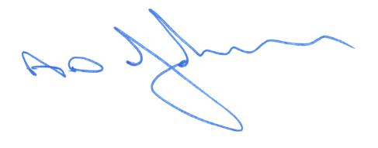
Tony Johnson
Head of Service

I declare that the school is acting in loco parentis and agree to the bullet points above.

Signed …………………………………On behalf of …………………………………………….. School
…..
Print Name………………………………………………………………… Date………………………….

Bradford Council is fully committed to compliance with the requirements of the General Data Protection Regulation and the Data Protection Act 2018. “To learn more about how we use your information, go to www.bradford.gov.uk/privacy-notice and the Music & Arts Service Privacy Policy go to https://www.bradfordmusiconline.co.uk/site/changes-to-data-protection-legislation-25-may-2018/

