Our ref:  Your ref: | Department of  Children’s Services  – Aiming High for Children  Music & Arts Service  Fairfax Learning & Development Centre,  Flockton Road, Bradford, BD4 7RY  Tel: 01274 434 970  Fax: 01274 408 335  Email: schoolsmusicandarts@bradford.gov.uk
11 March 2019

Dear Headteacher

PERFFORMANCE OPPORTUNITY - THIS IS BRADFORD – THIS IS US

FRIDAY 7 JUNE 2019 – CITY PARK, BRADFORD

Does your school have any groups that perform and reflect the cultural backgrounds of pupil’s heritage of the school/district? If so we would like to invite you to join us in celebrating Bradford’s cultural diversity – this can be a music or dance group such as Ukrainian Dance, Eastern European vocal. Bollywood etc. Performances should be a maximum of 7 minutes each. We are hoping the programme will encompass a wide variety of schools and talent across the district and the main focus of the day is the culture of Bradford so any performance you put forward should reflect this. There are limited slots available and they will be chosen to show a balanced range.

Arrangements for all transport and supervision will remain the responsibility of each individual school.

If you would like a performance slot you must provide staff to accompany your students and they remain your responsibility at all times. Appropriate performance licencing will have to be completed in due course.

It would also be great if your school were taking part in the whole day. Please click here for further information on how to join in the whole day https://www.bradfordmusiconline.co.uk/site/this-is-bradford-this-is-us/.

We are expecting a good response to this opportunity, therefore, requests can only be only be considered if they arrive before the closing date and performances will be selected to create a balanced and varied programme. Please complete the form below and return it by post, fax or email to the address above no later than Friday 12 April 2019.

We will be in touch as soon as possible after the closing date to let you know whether or not you have been successful and to give out further details as necessary.

I look forward to hearing from you.

Yours sincerely

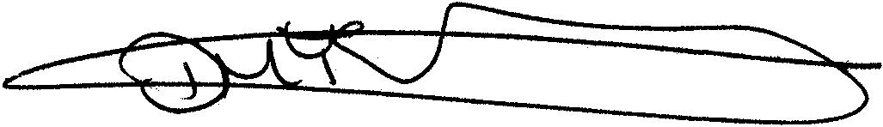

Debbie Bellwood
Business Manager
Music & Arts Service

Bradford Council is fully committed to compliance with the requirements of the General Data Protection Regulation and the Data Protection Act 2018. “To learn more about how we use your information, go to www.bradford.gov.uk/privacy-notice and the Music & Arts Service Privacy Policy go to https://www.bradfordmusiconline.co.uk/site/changes-to-data-protection-legislation-25-may-2018/

MUSIC & ARTS SERVICE
Fairfax Learning & Development Centre, Flockton Road, Bradford BD4 7RY
Tel: 01274 434970
Fax: 01274 408335

REPLY SLIP - THIS IS BRADFORD – THIS IS US

PERFORMANCE OPPORTUNITY – 7 JUNE 2019

SCHOOL: …………………………………………………………………………………….

DESCRIPTION OF PERFORMANCE:

…………………………………………………………………………………………………

…………………………………………………………………………………………………

…………………………………………………………………………………………………

…………………………………………………………………………………………………

…………………………………………………………………………………………………

ANY FURTHER INFORMATION/YouTube/Video Link to previous work:

…………………………………………………………………………………………………

…………………………………………………………………………………………………

…………………………………………………………………………………………………

NAME OF CONTACT PERSON: …………………………………………………………

BEST TELEPHONE NUMBER TO CONTACT YOU: ……………………………………

EMAIL ADDRESS: …………………………………………………………………………

Please complete and return by Friday 12 April 2019 to:

Debbie Bellwood
Business Manager
Music & Arts Service
Fairfax Learning & Development Centre, Flockton Road, Bradford, BD4 7RY

Or Email to schoolsmusicandarts@bradford.gov.uk

Or fax to 01274 408 335

