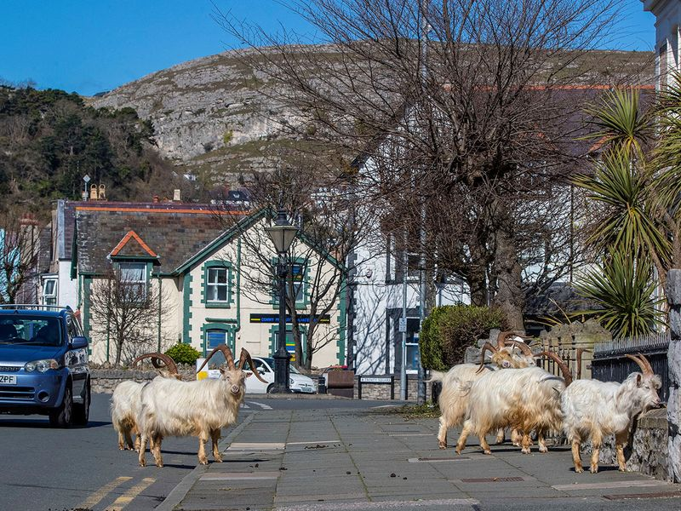
‘’ Goats in a ghost town :Animals take over deserted Welsh resort ‘’ 01 April 2020

Wild animals take back control of Mexican resorts: Crocodiles and jaguars roam deserted tourist hotspots as turtles lay their eggs in front of a luxury Cancun hotel 01 APRIL 2020
