CREATING A HUMAN LIKE FIGURE
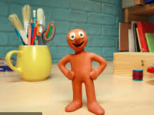

This idea is based on the popular children’s character MORPH from the 1970s and 80s UK TV
You need
Placsticine or Giotto Patplume Modelling Material (This material never goes hard but keeps its modelled shape)
Pencil
Follow these simple instructions; it can take a good hour to produce a quality piece
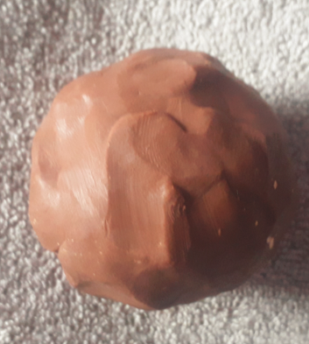
1. Create a ball of modelling material. If you play with it for about 5 minutes before creating the ball you will soften it up and it will be easier to use
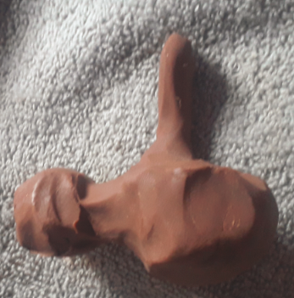
2. Pull out a spherical head shape then 4 cylindrical shapes for the arms and legs. Like the original morph your character is made from one single ball of material with the exception of the eyes

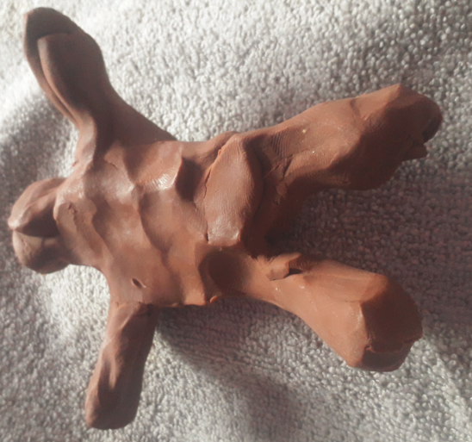
3. Now pull out the other arm and 2 legs. Try to make it in proportion. Careful not to make arms or legs too thin

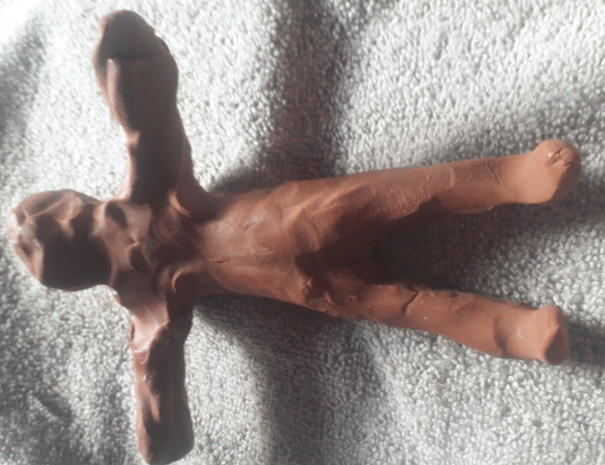
4. Start to smooth the figure down. Be sure to keep the cylindrical quality to the arms and legs. If you have too much modelling material on one side simply use your thumb to move it to where it is needed

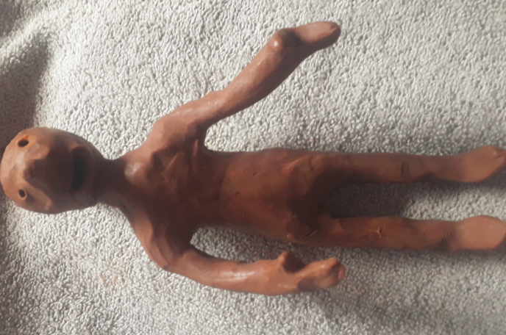
5. Use a pencil to create the mouth and eyes. Create hands and wrists, feet and ankles. Pinch the face to create the nose.
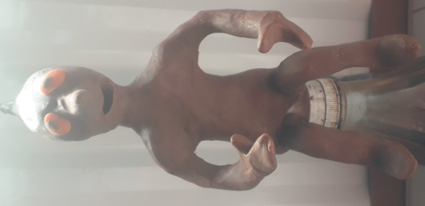
6. Use a different colour to create eyes. Pop a tiny piece of another colour in to create pupil. White would be best but I only had access to orange
7. Your character is complete but remember it can MORPH that means you can change its shape whenever you want. If you do this be sure to take a picture of it after each change.

ENJOY TB 29.03.20

