CREATING A CLASY PHOTO FRAME
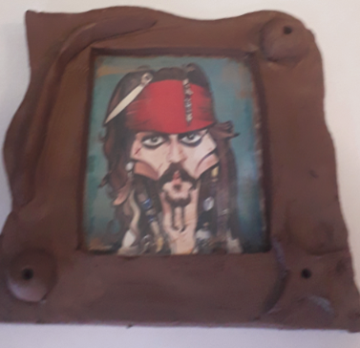

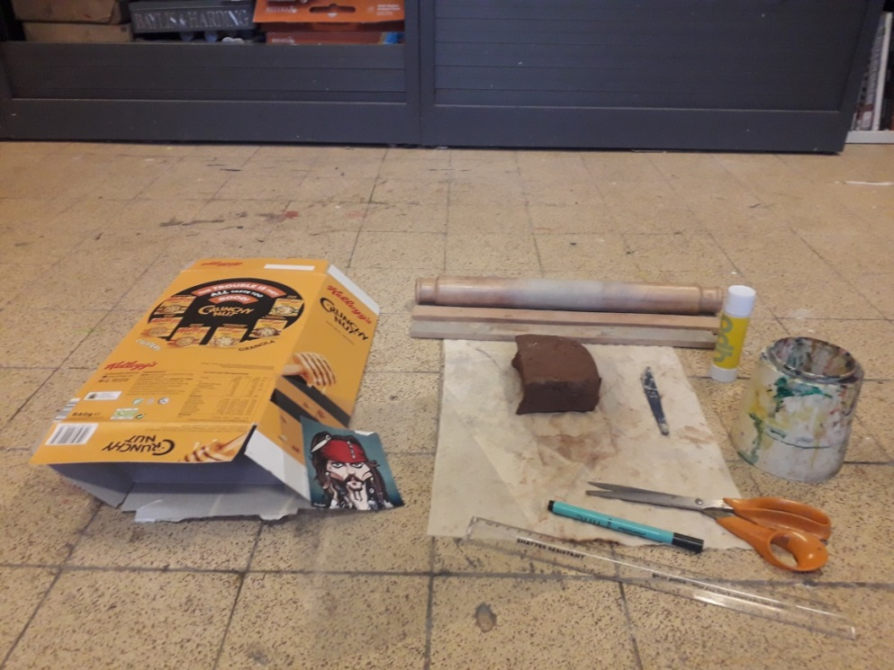 | You Will Need  . Clay or Salt Dough  . Rolling Pin  . Fabric cover  . 2 equal sticks  . Ruler  . Pen  . scissors  . plastic Knife  . Prit Stick  . Water  . Cornflake box  . Transparent plastic ( Window from an ASDA cake box )  . Photo  . ADULT HELP
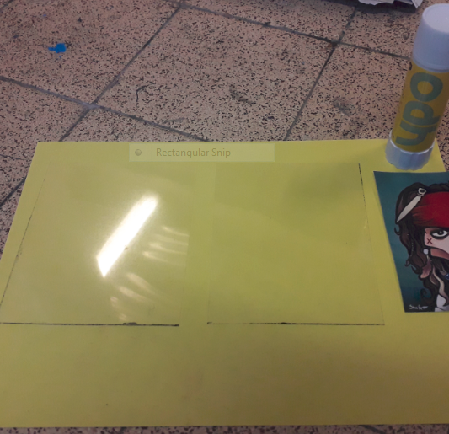 | - Create 2 equal sized rectangles of plastic at least 1 cm larger than your photo  ADULT HELP WITH CUTTING
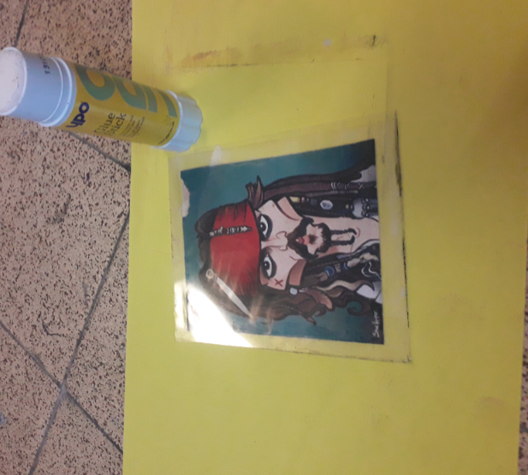 | - Glue the photo to one piece of plastic and then glue the other piece over
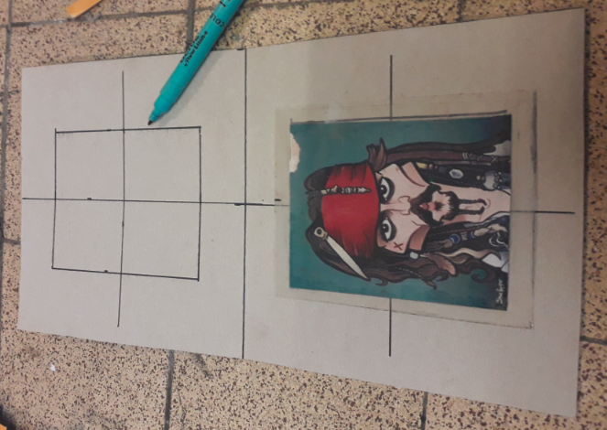 | - Take your cornflake box and fold in half, position the photo on one side ensure it is central  Draw a rectangle.  You will need to use a ruler here to ensure lines are straight by measuring
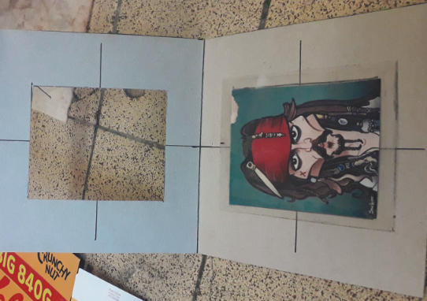 | - Cut out the rectangle  ADULT HELP WITH CUTTING
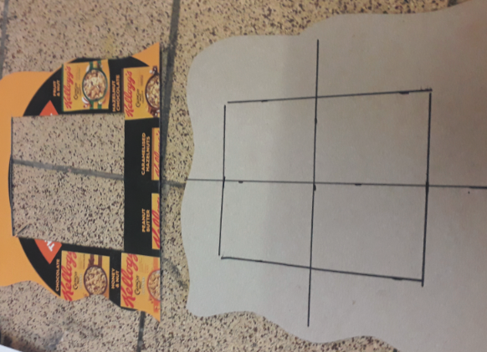 | - You now have two templates with a simple pattern cut at the side , keep one flat edge  ADULT HELP WITH CUTTING
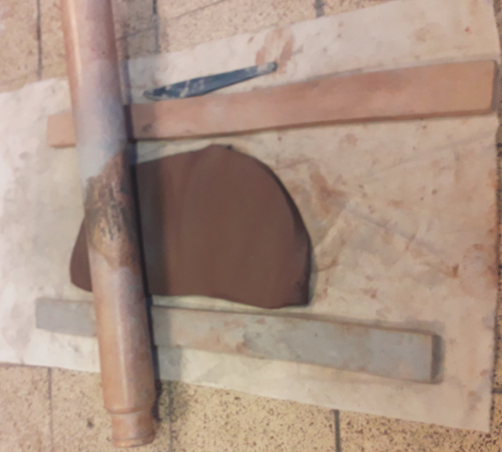 | - Place the clay or salt dough between the two sticks. By rolling only up and down you will ensure the clay or salt dough is equal thickness throughout. Stop when the rolling pins touch both sticks at same time
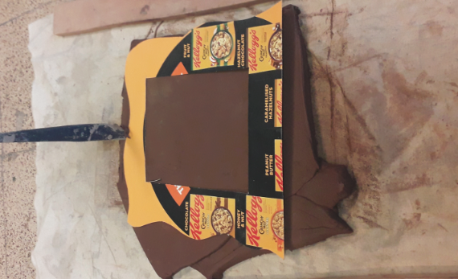 | - Carefully cut out the template with the window. Always pull the knife away from you. A clean cut is given if you pull and don’t push having your knife vertical  ADULT HELP WITH CUTTING
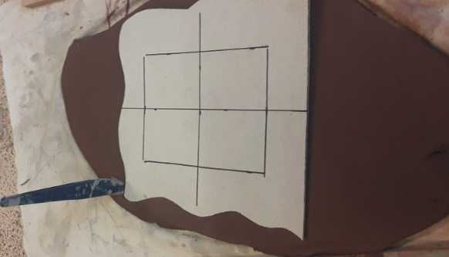 | - Now carefully cut around the back piece template  ADULT HELP WITH CUTTING
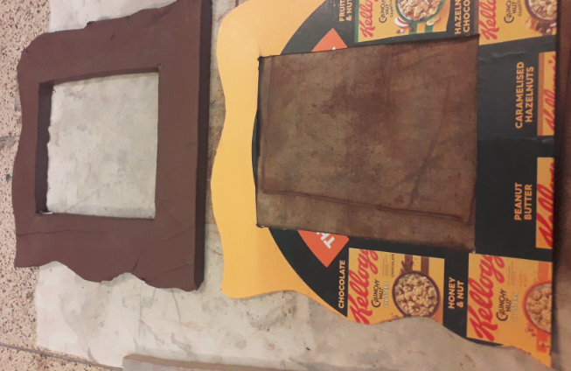 | - Gently trace around the window on the back piece , do not cut through  ADULT HELP WITH CUTTING
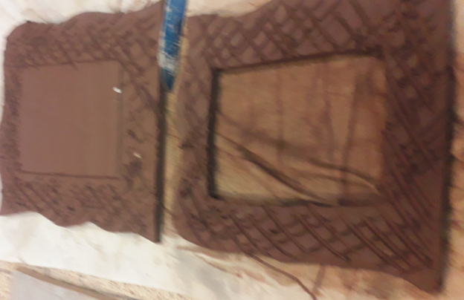 | - Score both surfaces gently with your plastic knife  ADULT HELP WITH CUTTING
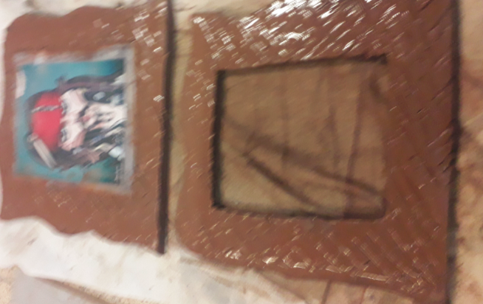 | - Place your photo down on the back piece and add water to both surfaces.
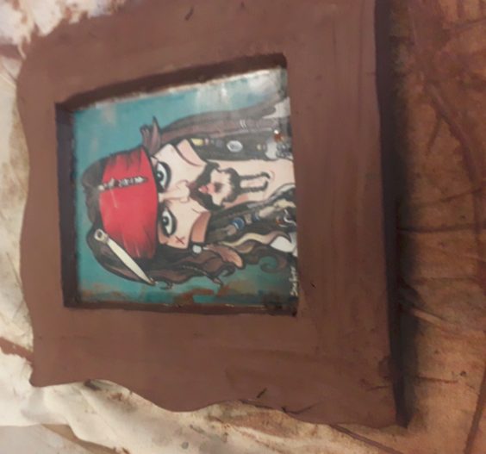 | - Carefully stick together using your plastic knife to smooth the pieces together. there must be no gaps between the two pieces of clay
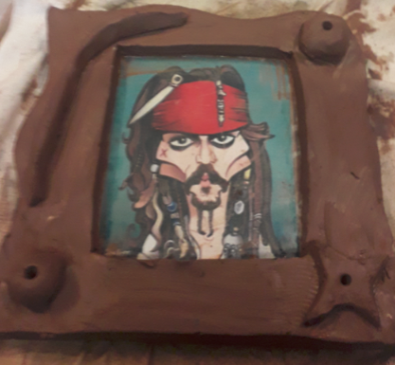 | - Now you can decorate the frame with other pieces of clay or salt dough. Remember anything you add must be  Scored  Slipped ( Water )  Stuck  Smoothed  You could stick other things in the wet surface like shells  LEAVE TO DRY FOR APPROX 3 DAYS  PAINTING OPTIONAL

