Fold A4 paper twice to create 4 sections. In each section come up with one idea on sea creatures. Spend only 5 mins and work in pen to get ideas down quickly. Remember you can do the picture portrait or landscape. Use Google if available to help you with ideas.
1

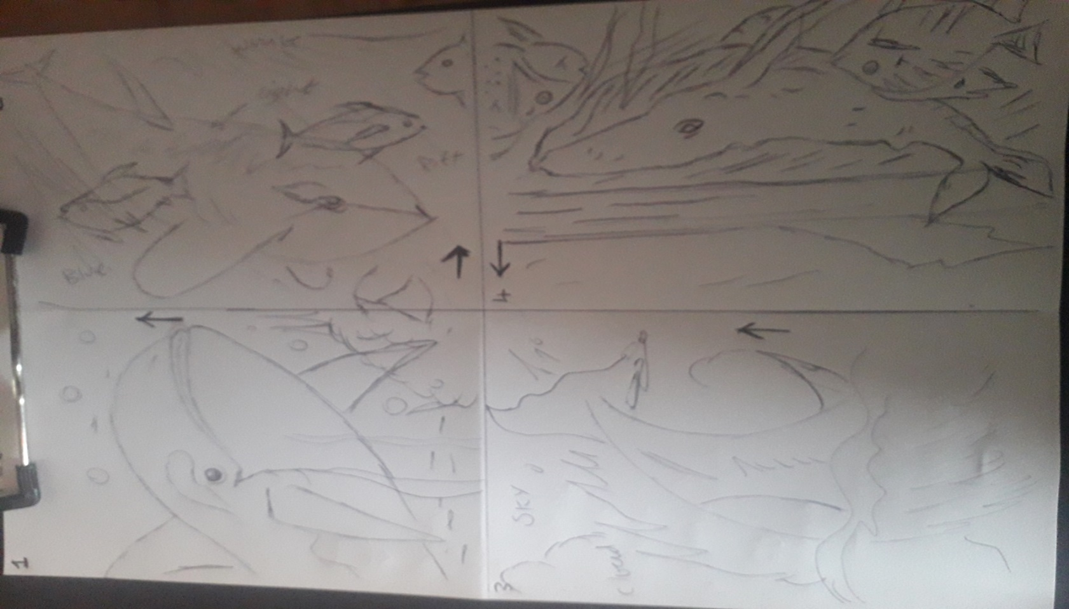

I have chosen number 4 as the starting point of my finished piece. Notice the overlapping i.e. the fish and seaweed go in front of the whale. Notice the fish goes off the page. These two simple effects are to create more interest in your picture.
2
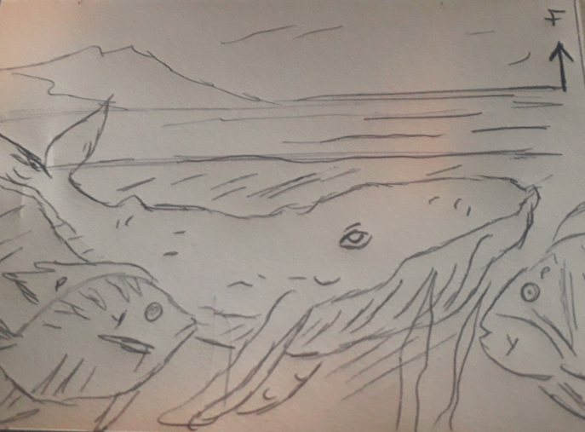

You will need
A4 paper
Selection of colour pencils
HB pencil
Sharpener
Rubber,
Piece of kitchen roll or a tissue
Preliminary sketch.
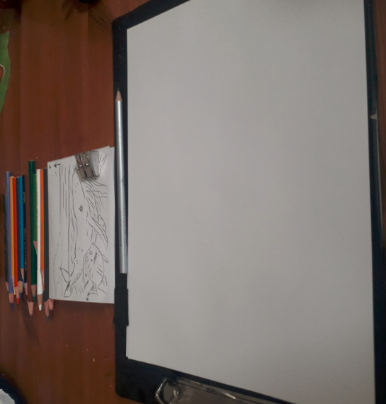
Now sketch the main details lightly in blue pencil as this will blend into your scene
3
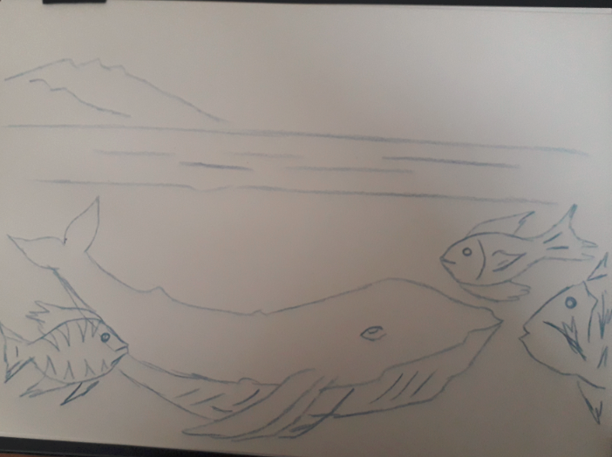
Now colour the sky, I chose purple and light blue but the choice is yours. I used the side of the pencil lightly moving in a diagonal way using my figure to stay in the lines.
I NEVER PRESS HARD WITH PENCIL IF I WANT A MORE VIVID COLOUR I POUT ON LOTS OF COATS
4
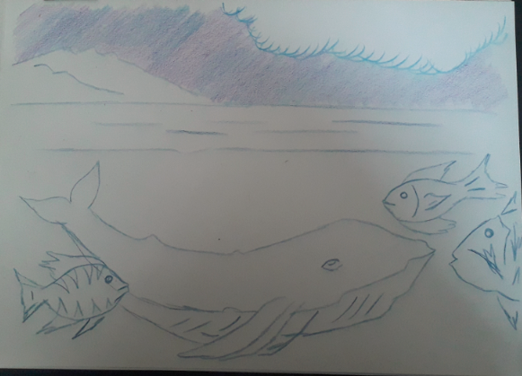
TOP TIP: Leave an uneven gape of approx. 1 cm around the edge of your work it looks good and avoids getting pencil on the table
Now colour the land in the distance. To create the grass I used light green, dark green and blended in yellow. Don’t over too many times as you want a hazy distance effect
5
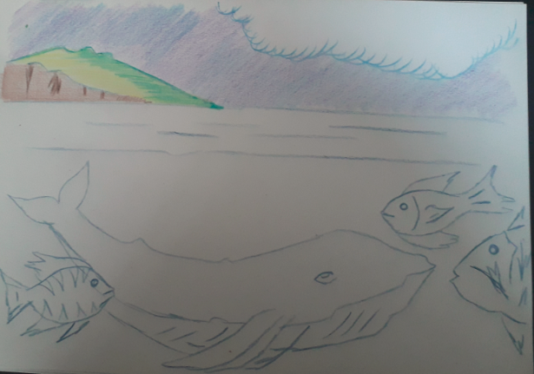
Here I used long horizontal strokes with side of pencil using light blue. I used the tip on the pencil to add ripples in dark blue
6
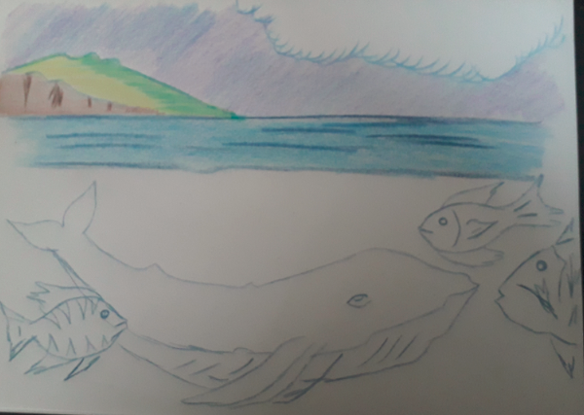
Here I used long diagonal strokes with the side of the pencil in light blue and purple to create the underwater. At the bottom I put a very light coat of black on first to create the darkness of sea depths
7
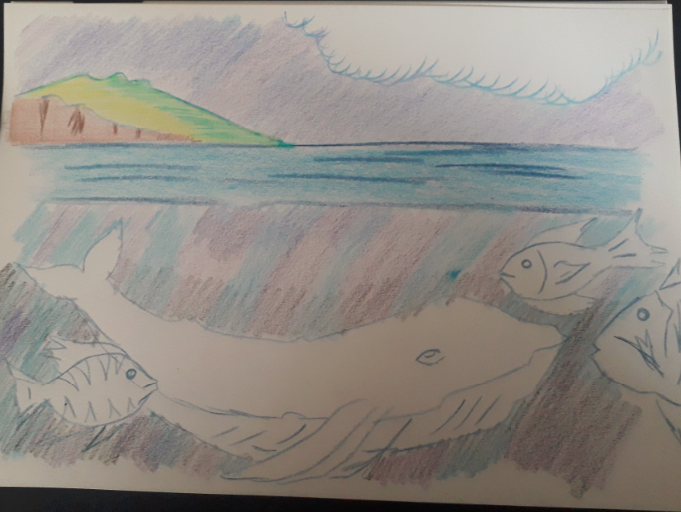
Here I coloured the fish in using small circular movements putting the lighter colours on first. You could add cross hatching to create the idea of darkness and dimensions
8
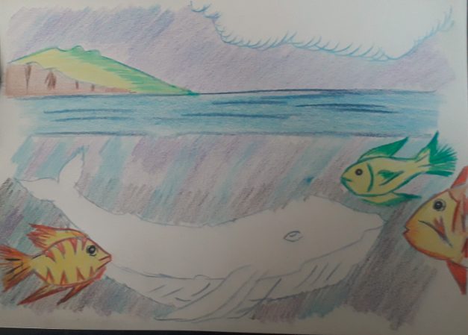
TOP TIP: ADDING A COAT OF YELLOW GIVES A GOOD GLOW TO ORANGES AND GREENS
Here I used A black pencil for the top of the whale but used it lightly then more coats for the underside of the black. Where the whale would be white I used a HB pencil very lightly
9
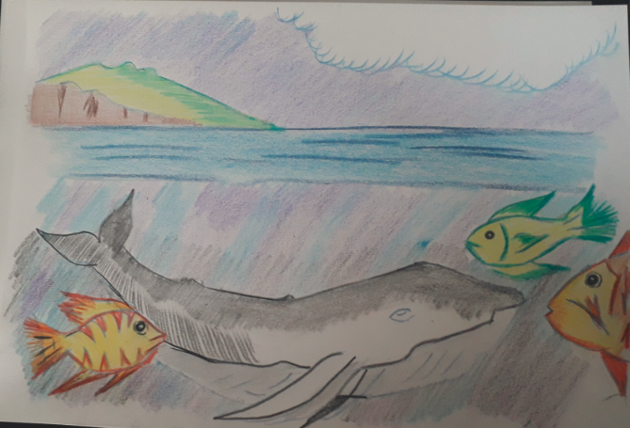
Now I used a tissue to blend the colour in by rubbing it into the paper
10
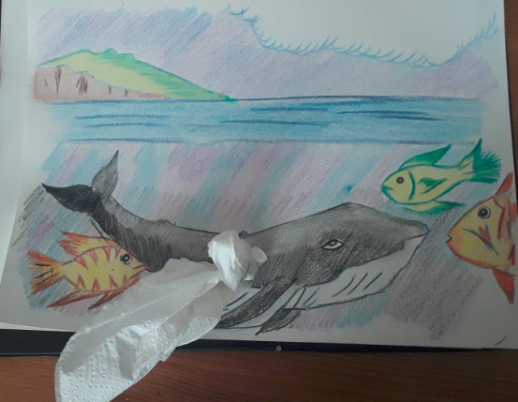
TOP TIP: Start with light colours first otherwise you could dirty your bright colours

Now add details like sea weeds, bubbles and eyes
11
COMPLETE
