DRAWING A REALISTIC FOX
STAGE BY STAGE
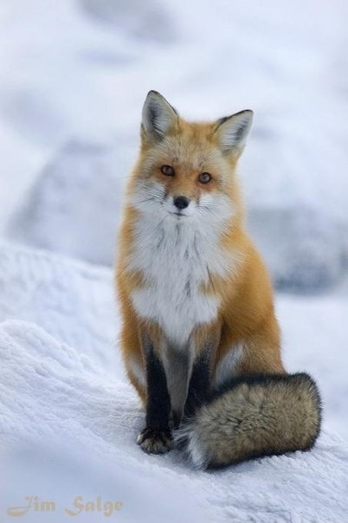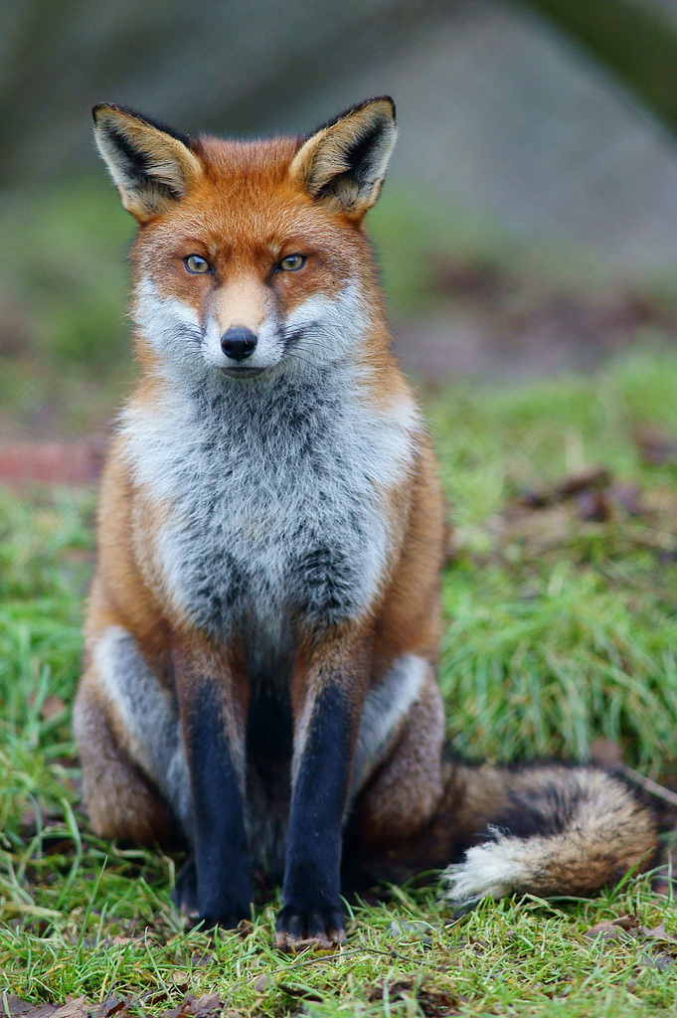
YOU WILL NEED
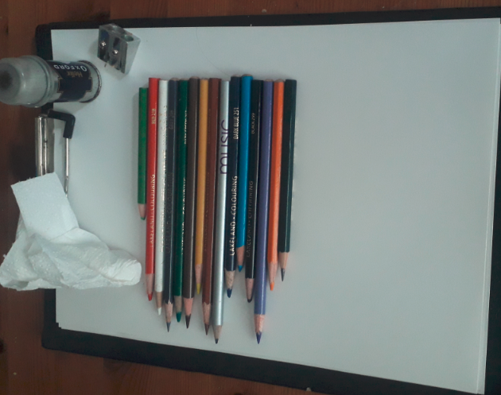

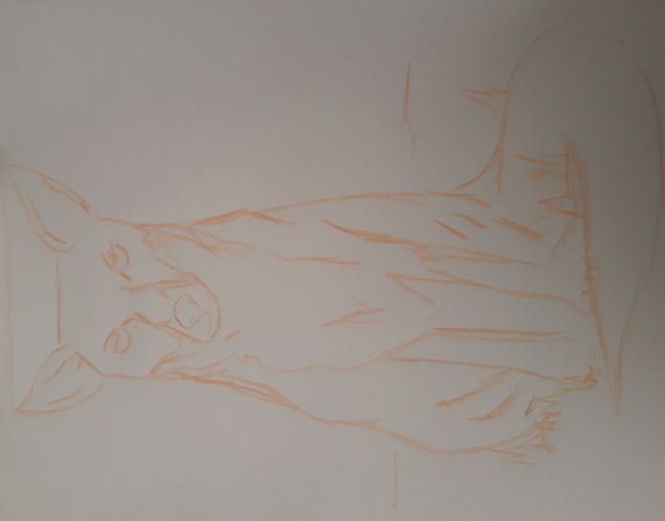
STAGE 1
Using a photo as a starting point draw the basic detail of the fox with an ORANGE pencil.
You could split into shapes and lightly draw guidelines. I started with the nose and used a guide line to ensure eyes were level.
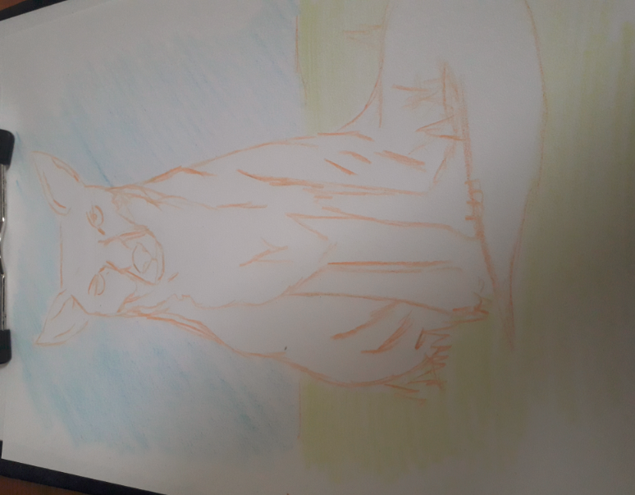
STAGE 2
Rub out and guidelines and colour sky and land with a light coat of light blue and light green. I used diagonal strokes for sky and horizontal for land. I USE MU FINGURE TO ENSURE I DO NOT GO TO PAPER ENDGE
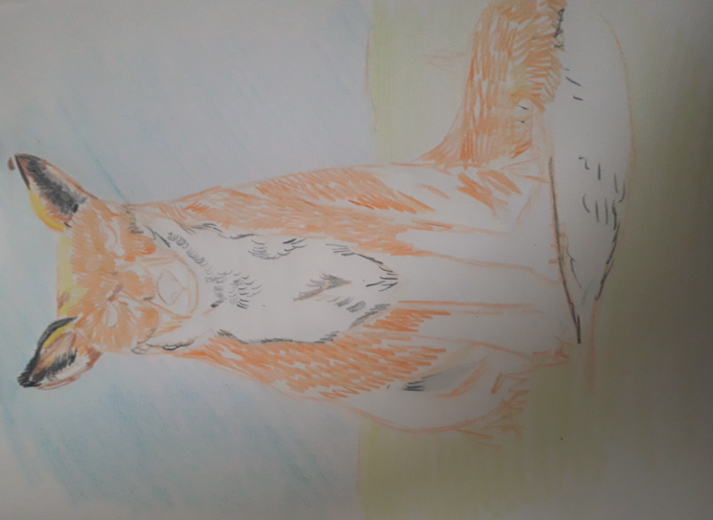
STAGE 3
Now using the point of the pencil add the fur in small rows of strokes. Look at the directions the fur goes and copy this
I have exaggerated the colour and made my Fox more orange
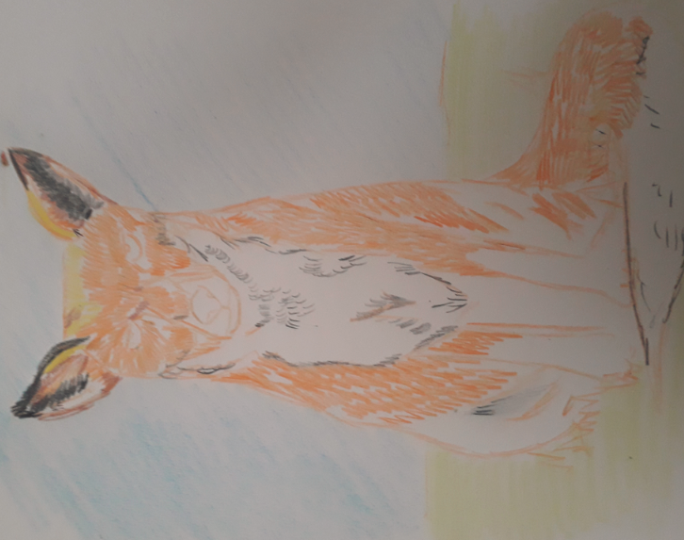
STAGE 4
I added a variety of colour into the fur. I used the tissue to rub in the colour then added sharp strokes with a sharp pencil
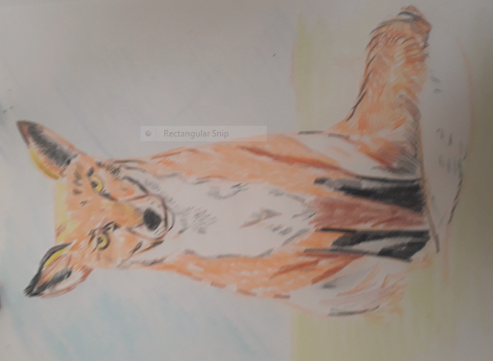
STAGE 5
I now add all the extra details, for the eyes I used yellow but be sure to add the black in the centre with a highlight of white
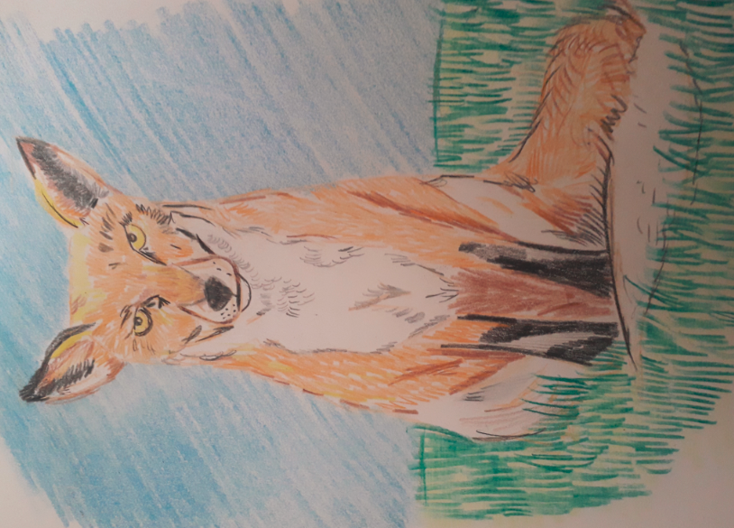
STAGE 6
Finally I made the sky more vivid by going over again. I then used a sharp dark green to but on the blades of grass. Be sure to overlap them over the fox.

