DRAWING AN ELEPHANT
You need
Paper
HB Pensile
Tissue
Rubber
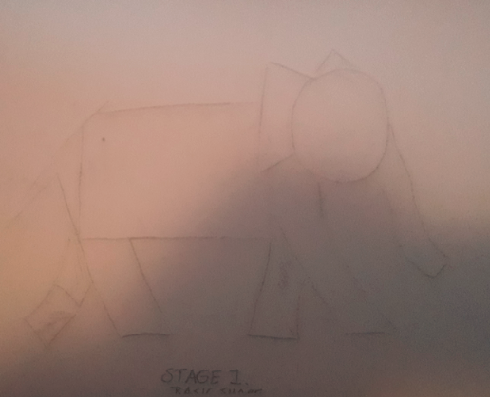
- Create the basic shape using a rectangle for the body
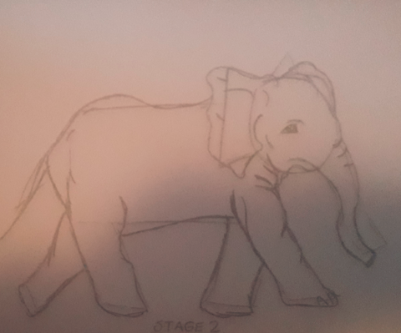
- Using the shapes as a starting point add the details and make legs etc more realistic
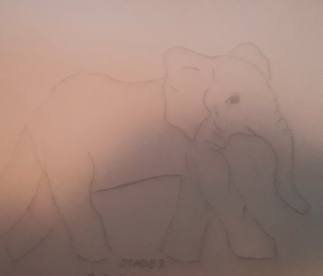
- Rub out the original guide lines
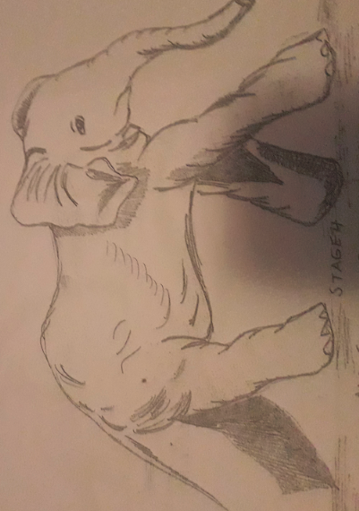
- Use side of pencil and cover the whole piece with a light coat . Use a tissue to rub the pencil mark in using circular movements. Using point of pencil and dark areas. You could use rubber to pick out highlights

