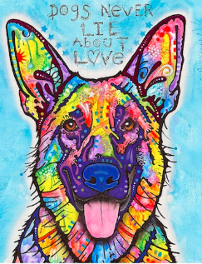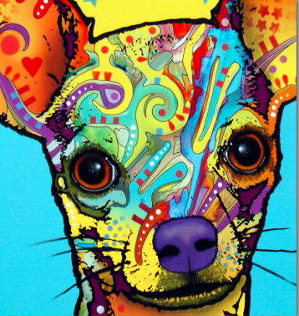
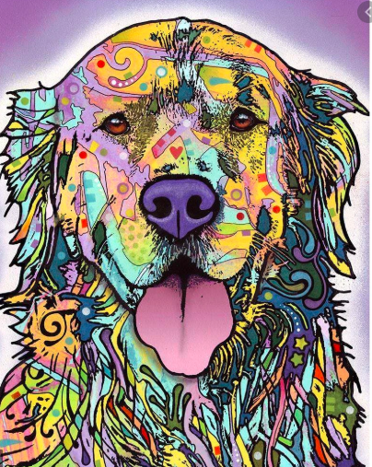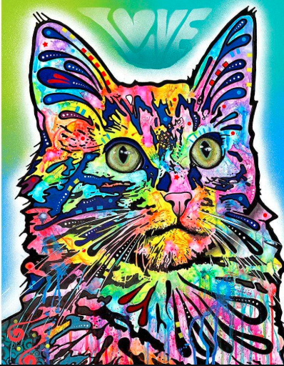
Inspired by his love of dogs and the urban landscape in which he was born, raised and still calls home, pop artist Dean Russo of Brooklyn, NY creates vibrant, colorful animal portraits as vivid and unique as our pets' personalities.
Dean Russo is an American pop portrait artist who's known for his use of a mix of different bright colors in his artwork. His works lie somewhere between realism and abstract coloring. He has a strong background both in graphic design and fine art, skills he has extensively explored in his works.

