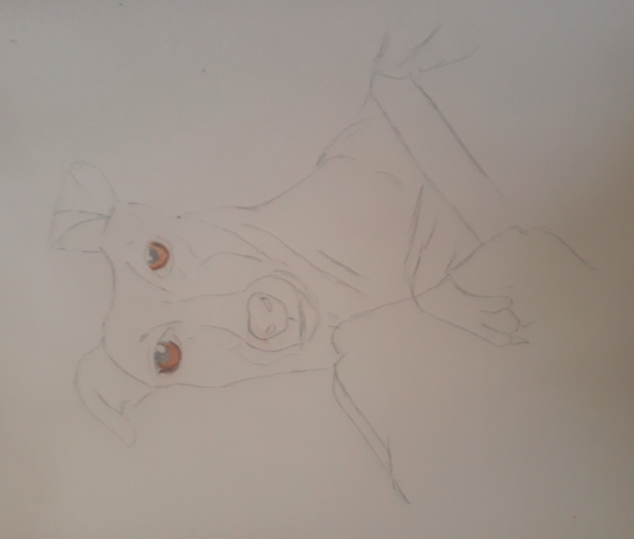
STAGE 1
Here I worked from a photograph and produced a simple line drawing in HB pencil.
I did though add the detail of the eyes in colour pencil.
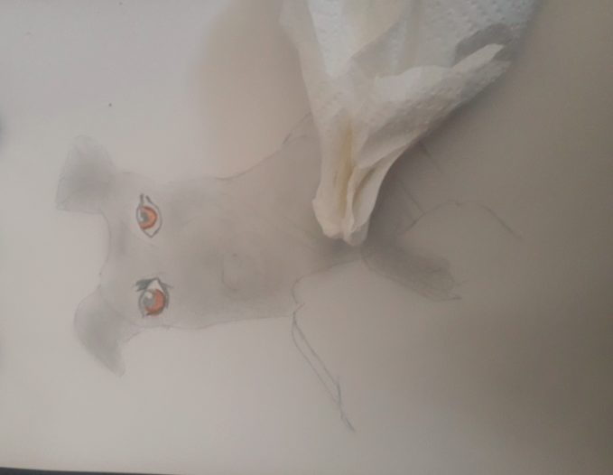
STAGE 2
Using side of the pencil cover the body in one light coat of HB pencil; use tissue to rub it in.

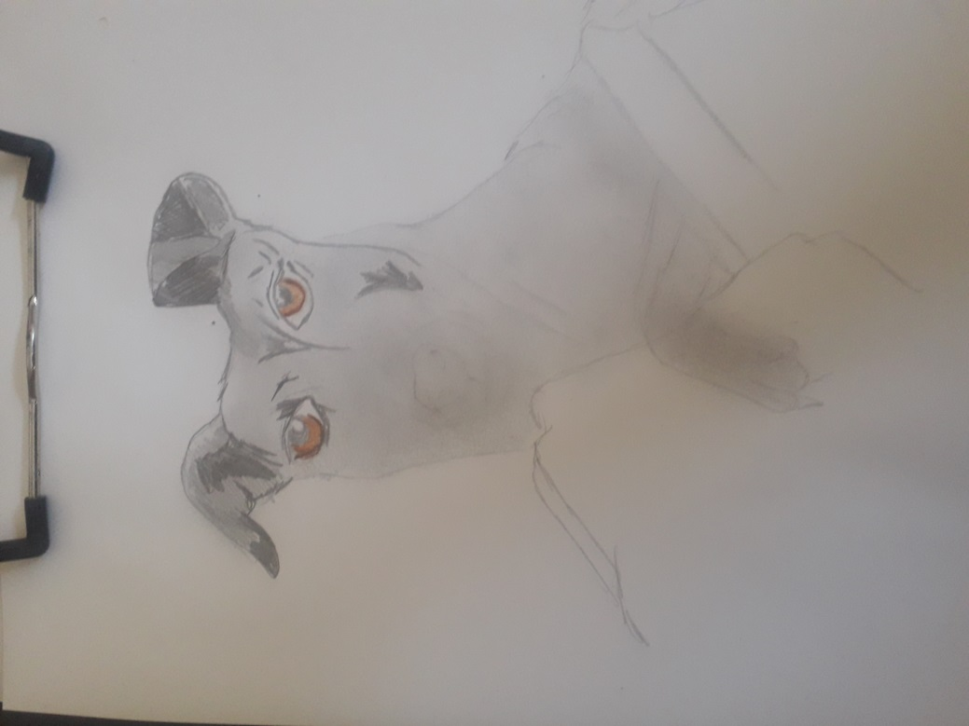
STAGE 3
Using HB start to add the detail of the fur making sure to pick up the light and the dark.
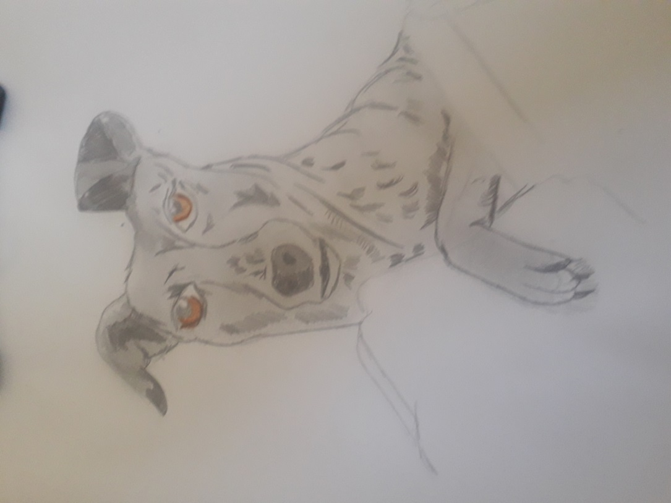
STAGE 4
Using cross hatching and curved strokes complete the fur.

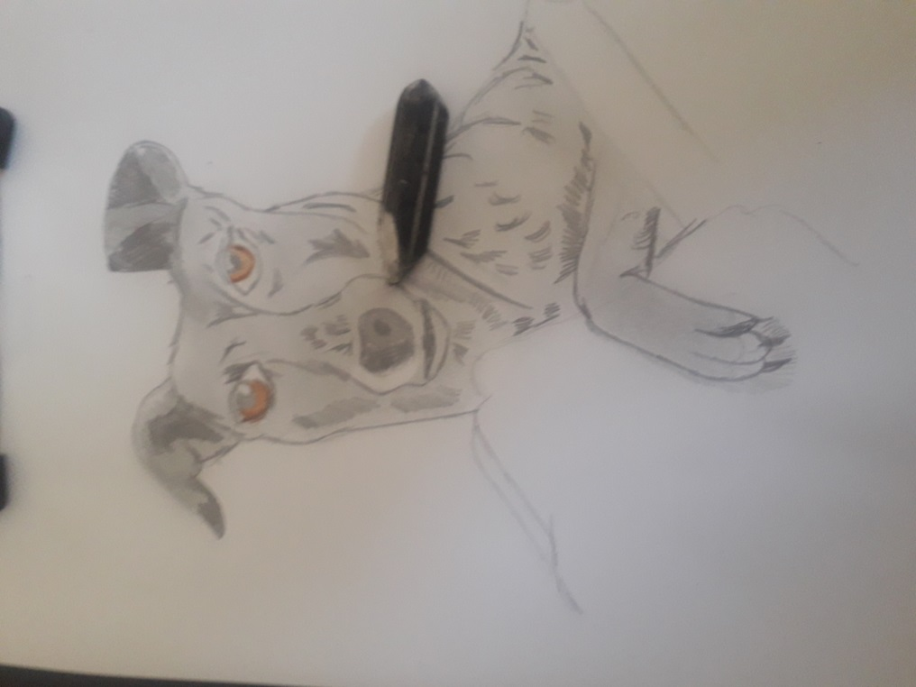
STAGE 5
Use a rubber to rub out the pencil where the fur is white
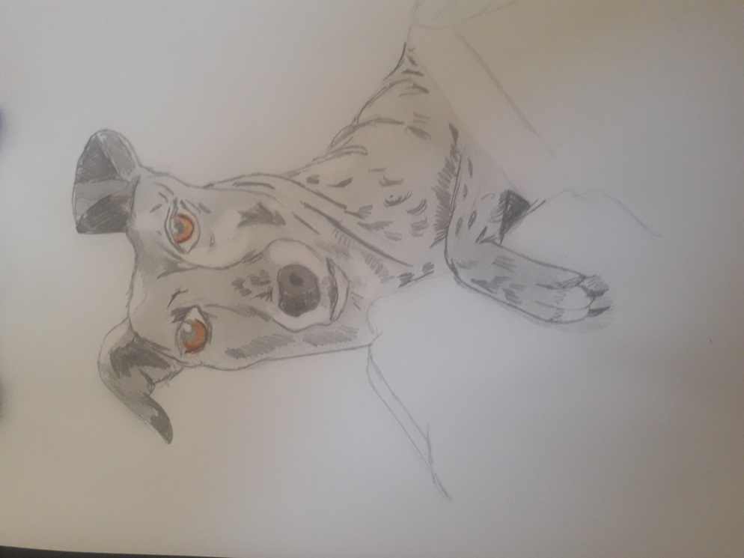
STAGE 6
Use same method to pick out any highlights.
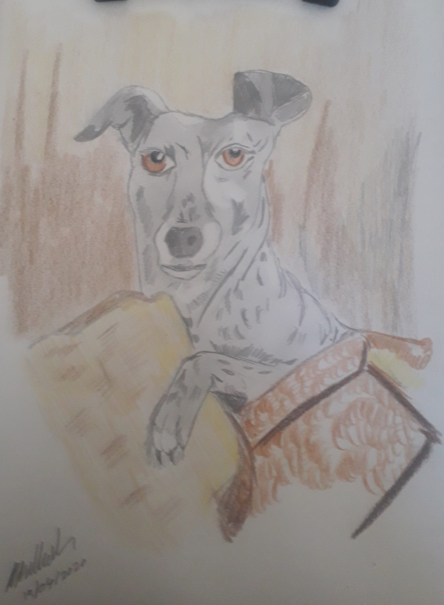
STAGE 7
Use colour pencil to create the background. In my composition the dog is reclining in cushions on a sofa. Though the dog in question is a colourful young lady I have done her fur grey to contrast with the colours of the background.

