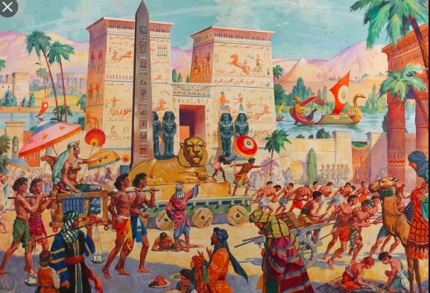
CREATIVE WRITING

Have a really close look at this picture
Try answering a few questions about this picture
Who is the lady being carried by the four men?
What game are the two children playing, what are their names?
Who is the man on the camel on the right, where as he come from?
Who could be on the boats in the distance?

Now pick any person in this picture give them a name and a family background and write a story about them. Use all you know about ancient Egypt to try to make your story accurate but exciting.

Here Are some more ART IDEAS
- Write messages in Hieroglyphs
- Practice drawing like the ancient Egyptians
- Research the different gods and draw them
- Create an Egyptian landscape making sure you show perspective
- If you can find the materials create a model in a show box of daily life in Ancient Egypt

