THE MAYA PEOPLE
Maya civilization

Description
The Maya civilization was a Mesoamerican civilization developed by the Maya peoples, and noted for its logosyllabic script—the most sophisticated and highly developed writing system in pre-Columbian Americas—as well as for its art, architecture, mathematics, calendar, and astronomical system.

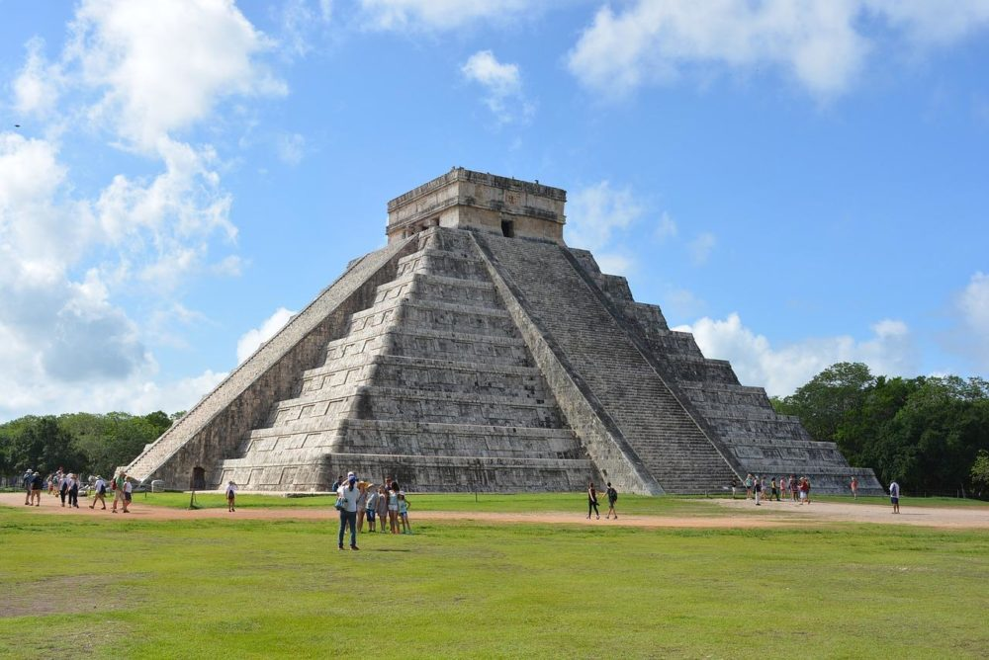
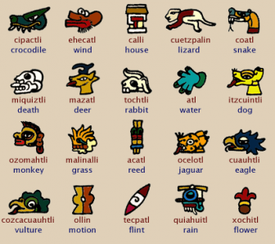
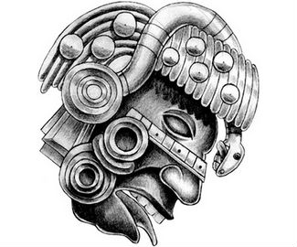
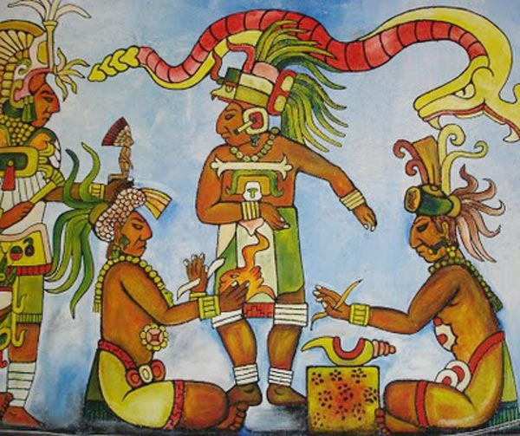
Here are a few images from Maya culture
Create your own artwork using them or research more about the civilisation
Why not combine the style of an established artist with Mayan civilisation
For Example :
A Maya temple with a Vincent Van Gogh style sky
A Maya portrait done like a comic strip

