MONTAGE COLLAGE
We are living thru historic times, we are all doing things we have never thought we would. The art projects in this section are designed to make a lasting record of our time in isolation. Just think in years to come you can show this work to your family and tell the story of the events of 2020
This is a very different type of collage to the portrait one. YOU WILL NEED ADULT PERMISSION AND HELP .First you need to gather together all the things on paper you can get that are linked to this historic time in history if you can print things off you could do some research on the internet.If you do this to save printing use the snipping tool and paste things into a word document so you can change size and position and fit lots onto one sheet. DO NOT RIP ANYTHING UP WITHOUT ASKING AN ADULT . You can also add writing to these collages. Think of adding diary type entries to the artwork , remember putting dates on is essential
There are two ways to approach this montage collage
1. Do one collage that you add to each week of your isolation
2. Do a collage each week that shows how things are progressing, you could colour co-ordinate them.
There are 3 types of montage collage suited to this situation
1. A drawn portrait of yourself or some one or something linked with our situation with the background collage
2. A simple montage collage of writing and pictures linked with the situation
3. A montage collage that tells a story
EXAMPLES OF THE 3 TYPES ARE ATTACHED
TOP TIP
line up all your things before you stick them down
Don't be afraid to overlap images as it is more interesting
Don't just stick to putting everything in rows
PERMISSION AND CUTTING HELP ESSENTIAL

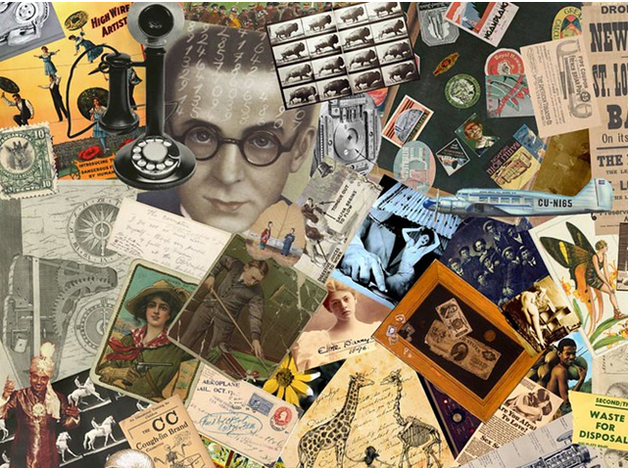
This Type of Montage Collage overlaps many pictures on a given topic and involves no drawing at all. The skill is putting it together in an eye catching way.

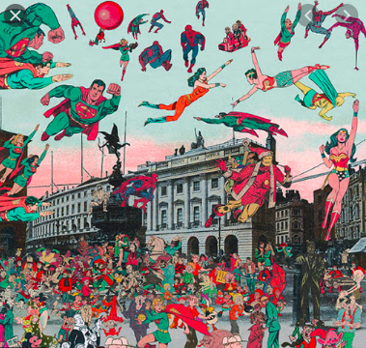
This type of montage collage creates a new picture by choosing a location for the background and sticking people and things on it. This is particularly effective because the background is black and white and the characters are brightly coloured . You could use your own drawings as well .

