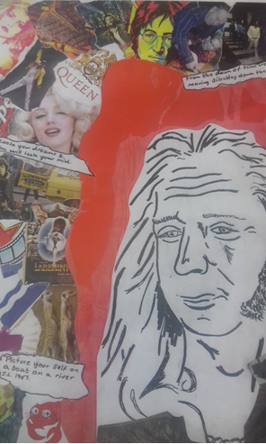
This is a self portrait with a montage collage of all my hobbies and interests in the background.

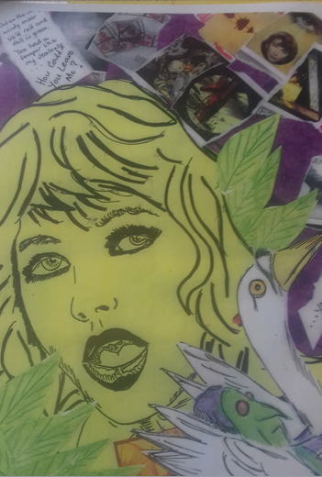
This is a portrait of a British artist and musician Kate Bush done in a school as part of a day celebrating GREAT BRITAINS.
In the background is a montage collage showing her creations and including lyrics from her music.

