Create A Real Superhero
We are living thru historic times, we are all doing things we have never thought we would. The art projects in this section are designed to make a lasting record of our time in isolation. Just think in years to come you can show this work to your family and tell the story of the events of 2020

For this piece of art you really need to think who are the heroes at the moment , IRON MAN is no where to be seen WONDERWOMAN as been rather quiet but our country is full of heroes of a rather SUPER kind. Create your own super hero or even a whole squad of them but base them on the real heroes Nurses , doctors , delivery drivers , shop assistants , Neighbours the list goes on and on.
You could use the costume or face of a fictional super hero and change it to your own design
Give them a catchy name
Give them a catch phrase
List their superpowers
Once you have drawn them you could write whole comic strips for them an update it daily or weekly

YOU COULD BE THE NEXT STAN LEE

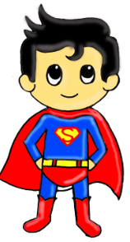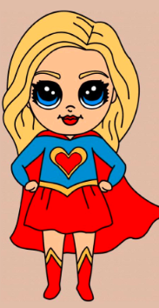
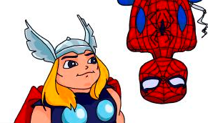
Example of a story in comic strip form
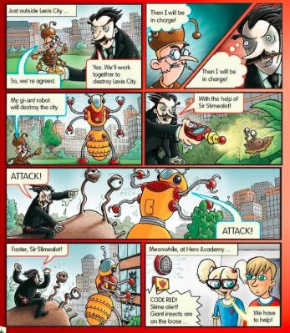
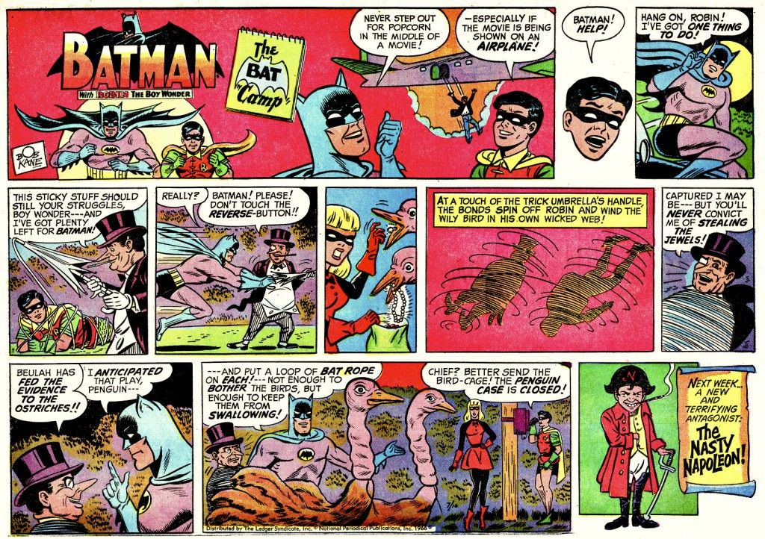
Notice in this one the end of the story tells you what comes next time

