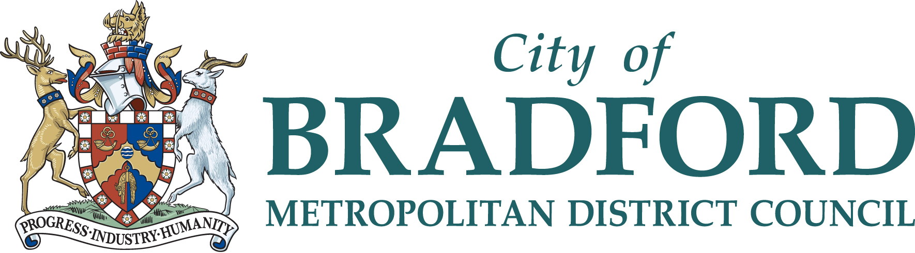
Music & Arts Service 21 Market Street, Shipley, Bradford, BD18 3QD
Tel: 01274 434970
Email: schoolsmusicandarts@bradford.gov.uk Website: www.bradfordmusiconline.co.uk

MUSIC CURRICULUM SUPPORT

SEPTEMBER 2021 – JULY 2022

Music Curriculum Support
Prices are based on the service delivering *30 lessons over an academic year *(This allows for staff sickness, training and events).

Music curriculum support teaching to the National Curriculum guidelines is delivered by an expert and experienced team of class music teachers in 3 hour morning and 2.5 hour afternoon sessions. Delivery is to Foundation, KS1 and KS2. Support for class music teaching is offered throughout the primary age range from Reception up to Year 6 and to Special Schools.

This offers a good opportunity for CPD when staff are present. Alternatively, packages are available to schools where lessons can be modeled. See the website at: https://www.bradfordmusiconline.co.uk/site/music-buy-back-202021/

Large group singing in conjunction with school staff is also available within the sessions (e.g. singing assemblies or choirs).

We recommend that lessons should be a minimum of 30 (KS1) and 40 (KS2) minutes in length and should take place with a class-size group in a designated music room/hall where music resources and instruments are available.

Termly Annual
Cost for morning session £2,618* £7,854*
Cost of an afternoon session £2,237* £6,711*

Special arrangements
For schools with other requirements, for example small schools, it is possible to discuss alternative arrangements with the Service.

Team teaching
In-school training to support and empower class teachers to deliver their own music lessons in school. After an initial meeting to establish the need in school, a music curriculum specialist will work alongside class teachers and provide one-to-one tailored support on how to develop their music teaching. This will involve demonstrations of ‘what a music lesson should look like’ and of resources and direct ‘team teaching’ based coaching to develop a progressive music curriculum in school and to build the knowledge, confidence and skills of how to deliver and assess it. This provision is built on a bespoke basis, analysing the needs of the staff and providing 1-2-1 support and whole school CPD.

Morning Afternoon
Cost per half term block £1230* £1230*
Cost per half term block if a part of a cluster £1025* £1025*

Charanga CPD sessions
The Charanga CPD session is aimed to provide a bank of resources and ideas for delivering music from Reception to Year 6 and is completely accessible regardless of your experience and ability in teaching music. It is a practical session and is delivered by a Music Curriculum specialist with years of primary teaching experience, particularly music delivery. All feedback provided by schools has been extremely positive and Music Audits have shown a sharp increase in teachers actively delivering music as a part of their weekly curriculum in school.

Updates on available dates, venues and costs are updated on www.bradfordmusiconline.co.uk, circulated amongst the music coordinators, email updates and BSO as available.

Singing Staff Meeting
The Singing Staff Meetings are an ideal opportunity to engage your staff in utilising the many available singing resources to support music and the wider curriculum. This practical session is led by a vocal specialist using staff voices to discover cross curricular singing activities that can be delivered by the class teacher. All resources used are appropriate to the primary environment and encompass all key stages therein, including whole school singing assemblies. The session can be booked to run during your normal staff meeting time slot, depending on Music & Arts Service staff availability.

1 x Singing Staff Meeting (1.5 hours max) - £102.00*

Supporting the Whole School Curriculum through Music
This CPD session is designed to support your staff in embedding music into the whole school curriculum through topic and other cross curricular links. In this session, your staff will discover the wide range of resources available to support their existing planning to provide a greater depth of learning for the children. Each school will receive a comprehensive list of resources available to their support topic, literacy and maths provision and receive training on effective ways to deliver the resources regardless of music background or confidence.

1 x Supporting the Whole School Curriculum through Music (1.5 hours max) - £102.00*

Bespoke Music CPD, Music Workshops and One-To-One Support
As each school has a different musical starting point, we are now offering bespoke CPD sessions that are individually tailored to suit the needs of the school. This can include

Cluster school support Cluster school CPD sessions
Support for a new Music Coordinator Teaching Music as an NQT
One off instrumental workshops Anything else by request……

Please contact the Music & Arts Service for individual support price.

*+ VAT for Academies/Free Schools and organisations outside of the Bradford LEA

For further information, or to discuss your individual requirements please contact:
Carl White – Head of Music & Arts Service (Acting) Tel: 01274 435022

CANCELLATION CLAUSE - Booking commits the school to one full academic year. Cancellation before that time will only be agreed in exceptional circumstances and must be put in writing and accepted by the Head of the Music & Arts Service. Full charges for the whole academic year will otherwise be fully payable.

Bradford Council is fully committed to compliance with the requirements of the General Data Protection Regulation and the Data Protection Act 2018. “To learn more about how we use your information, go to www.bradford.gov.uk/privacy-notice and the Music & Arts Service Privacy Policy go to https://www.bradfordmusiconline.co.uk/site/changes-to-data-protection-legislation-25-may-2018/

