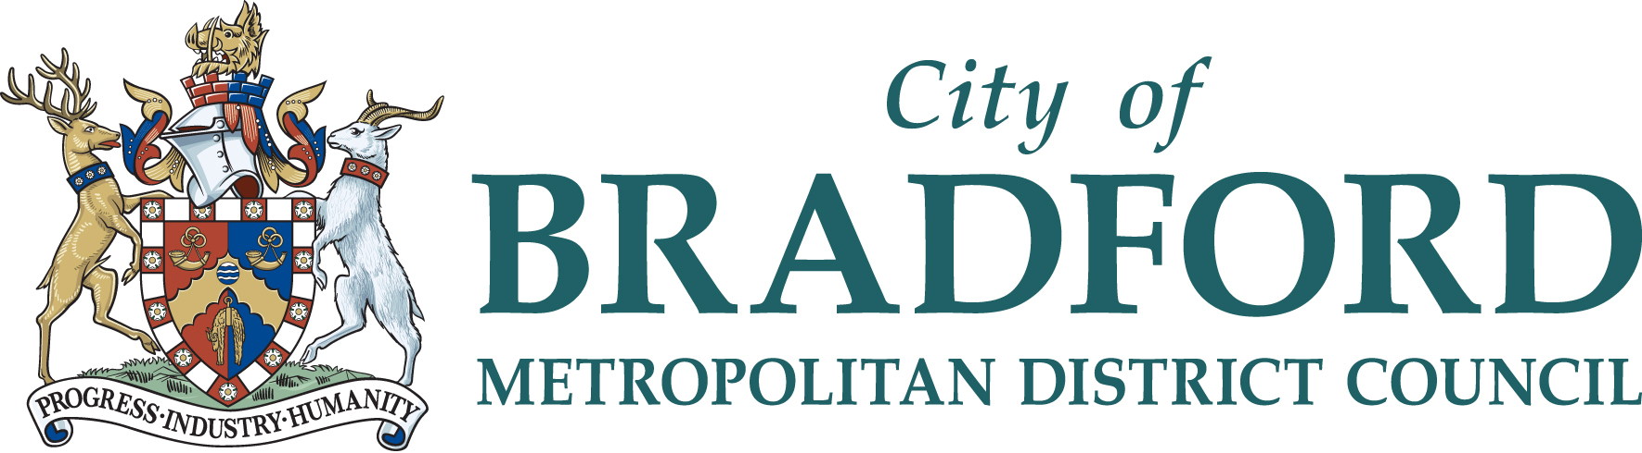
Music & Arts Service 21 Market Street, Shipley, Bradford, BD18 3QD
Tel: 01274 434970
Email: schoolsmusicandarts@bradford.gov.uk Website: www.bradfordmusiconline.co.uk

MUSIC THERAPY

SEPTEMBER 2021 – JULY 2022
Music Therapy can be purchased and is charged out at £650 per hour/per term (+ VAT for Academies/Free Schools and organisations outside of the Bradford LEA). Prices are based on the service delivering 30 sessions over an academic year. (This allows for staff sickness, training and events). The minimum session bookable for any one discipline is 60 minutes. This may be increased in blocks of 10 minutes which will be charged pro rata and the commitment is for the whole academic year. Please note these sessions are extremely popular and availability is limited so please reserve your time as soon as possible.

As part of staff training and moderation, lessons may sometimes be photographed/videoed.

Music Therapy has been an additional provision to Bradford schools since September 2020. A member of our team has qualified with a Master’s Degree in Music Therapy using the prestigious Nordoff Robbins approach and is working with Bradford Music & Arts Service to extend our support to children and schools. This opportunity is open to schools in both a SEND and mainstream setting.
Why use music therapy? Music therapy has been known to be highly beneficial to students and pupils who are often more hard to reach for a multitude of reasons. Music tuition is very useful for a lot of young people, however some might find that the teacher/student relationship that can restrict access for children who might live with conditions such as autism, global developmental delay, ADHD, attachment disorder, and many other conditions that can affect a child’s communication and subsequent wellbeing.
What is music therapy? Music therapy is an approach that comes with a Master’s Degree certified therapist, who works with children by using music as an alternative method of communication. The therapist will use call and response, structured improvisation and song writing in a non-verbal approach. They will also have therapeutic aims for the children they work with which are set by liaising carefully with other members of staff. There is a high standard of note taking, record keeping and safeguarding, which help to make subsequent examples and presentations to staff and families through recorded sessions. Presentations and performances aim to demonstrate the therapeutic process that the individual has taken since their journey with music therapy began and can show a great deal of progress with how they interact and communicate, all through the medium of music.
Music therapy can work in 1:1 sessions and small groups and produce a variety of outcomes, depending on group size. The focus is on the individual and how they feel a sense of interaction in a group setting. Bigger groups might be for an end of term performance.

For further information, or to discuss your individual requirements please contact:
Carl White – Head of Music & Arts Service (Acting) Tel: 01274 435022.

CANCELLATION CLAUSE - Booking commits the school to one full academic year. Cancellation before that time will only be agreed in exceptional circumstances and must be put in writing and accepted by the Head of the Music & Arts Service. Full charges for the whole academic year will otherwise be fully payable.

Bradford Council is fully committed to compliance with the requirements of the General Data Protection Regulation and the Data Protection Act 2018. “To learn more about how we use your information, go to www.bradford.gov.uk/privacy-notice and the Music & Arts Service Privacy Policy go to https://www.bradfordmusiconline.co.uk/site/changes-to-data-protection-legislation-25-may-2018/

