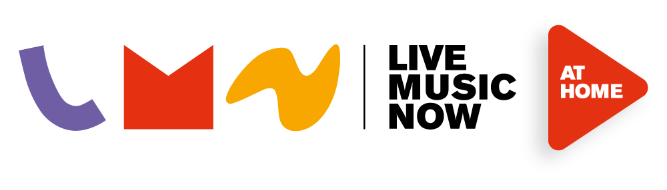

LIVE MUSIC NOW AT HOME
New - Free Online Video Library for Schools

www.livemusicnow.org.uk/lmnathomeschools

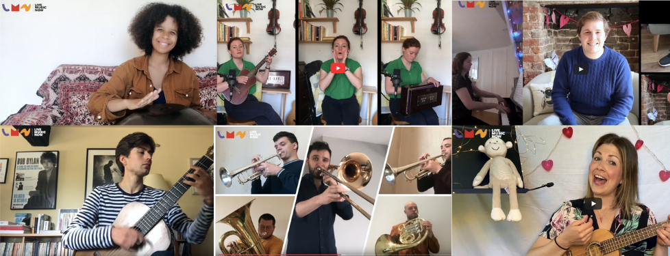

Live Music Now musicians are usually to be found visiting schools all over the UK performing participatory concerts and leading music residencies. Whilst they aren’t able to visit schools in person, we have commissioned them to create short recorded concerts and music sessions for schools and families to enjoy for free.

You can find the videos here with more videos added each week:

- Wide range of performances, instruments and musical styles
- Ranging from 15 – 30 minutes in length
- Accessible for children and young people with additional learning needs
- Inspired by the musicians’ visits to SEN schools
- Opportunities to join in and learn new things about music

This library is a new area of work for us, so if you have feedback or ideas for future videos, please let us know by emailing: schools@livemusicnow.org.uk

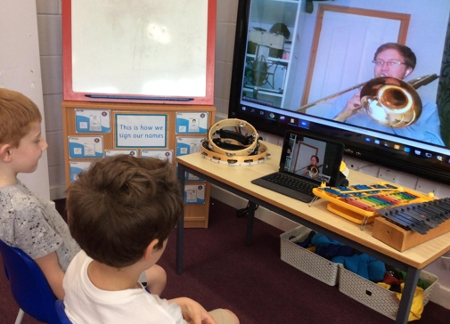
Live Online Sessions and Music Residencies

Live Music Now is now delivering live online music sessions directly into the classroom and at home with families via Zoom, Microsoft Teams and other online platforms. Read here about what we’ve been doing with SEN schools and families.
If your school or Music Education Hub is interested in finding out more, please contact schools@livemusicnow.org.uk

www.livemusicnow.org.uk

