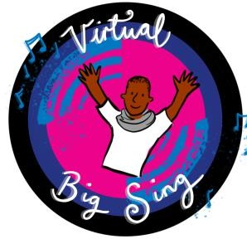

Dear Colleague

As your Music Education Hub we have partnered with Norfolk Music Hub and with great pleasure I invite you to take part in the Virtual Big Sing 2021 – VBS2021

VBS2021 is a fantastic opportunity to reintegrate singing back into your school and we are really excited to be a part of the event.

The event will expand the provision and reach even further than last year featuring an exciting mix of world-renowned artists and musicians from across the globe. Partnering with Charanga, NYMAZ, Mark De-Lisser Music for Youth, Viking Sound and Lighting and the uber exciting Abbey Road Studios. The event has also been expanded to offer two performances which will increase opportunities and accessibility for the different key stages and settings that you work with.

On July 1st 2021 there will be 2 interactive concerts with the Secondary Performance taking place at 11.00am and the Primary Performance commencing at 1.30pm (complex needs settings will be invited to both performances). The events themselves will last a maximum of 90 minutes. A comprehensive set of resources have been created to sit alongside the project including vocal, instrumental and movement to create a very personalised and engaging musical experience that pupils will never forget! The resources for this event will be available via Charanga from 12th April 2021. If your school doesn’t currently have Charanga then please contact us to help you get set up.

Details of all artists taking part will be released in due course, but I can confirm that the guests are really awesome…and even bigger than last year, representing a variety of genres, so the event is definitely not one to be missed! We are also adding an interactive Q&A session with all the artists giving children and young people the chance to communicate with the artists in a safe environment.

For further information and to sign up please follow the link below and keep checking ours and Norfolk Music Hubs social media channels for further information. Please do feel free to share the link with your schools, staff, peers and colleagues as we are looking to engage with as many children and young people from across the county as possible.

https://www.norfolkmusichub.org.uk/site/virtual-big-sing-2021/

In order that the event follows the Safeguarding guidelines, we require each education establishment to sign up via the link on Norfolk Music Hubs website (see above). The stream itself will be hosted on an unlisted YouTube live video link with all comments being filtered before being displayed. This, alongside the safety protocol that NYMAZ have adopted, will offer a stable platform enabling all children and young people to take part in the event safely.

On the day of the event itself, all registered parties will be sent the unique event URL via email so that they can enjoy the experience from anywhere in the country on any device.

If you require further or more specific details then please do feel free to contact either myself or my colleagues Tim and Krista at Norfolk Music Hub who are leading on the event at thebigsing@norfolkadvisory.com.

I’m really looking forward to working with as many of you as possible and super excited to launch what looks set to be an extraordinary event!

Best wishes

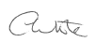
Carl White
Head of Bradford Music & Arts Service


