Boy 87 Big day out!
Tuesday 21st June 2022
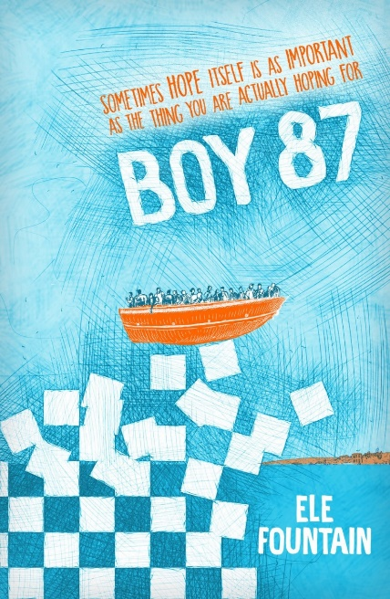

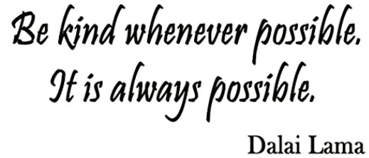

Programme of Events
Plan for the day
9:30am - 11:00am – Musical performances
- The Plumber Drummer
- Bollywood Brass Band
- Punjabi Roots Academy Dhol Drummers

11:00am - 11:10am – Ele Fountain Boy 87 author
11:10am – 11:20am - Sharena Lee Satti poetry recital
11:20am – 11:50am - Big Sing with Sam Dunkley
11:50am – 12:10pm – Dance United Yorkshire with Romina Thornton
12:10pm - 12:35pm - Lunch with Dixons Music Primary Choir performing
12:35pm - 1:00pm – Kirsty Taylor poetry recital
1:00pm – 1:20pm – Punjabi Roots Academy Banghra dance workshop
1:20pm – 1:30pm - Key speaker
1:30pm – 1:40pm Closing remarks with Linda Wright
1:40pm – 3:00pm – Musical performances

- The Plumber Drummer
- Bollywood Brass Band
- Punjabi Roots Academy Dhol Drummers

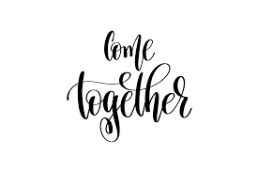

Sing by Gary Barlow

Some words they can't be spoken, only sung
So hear a thousand voices shouting love
There's a place, there's a time in this life
When you sing what you are feeling
Find your feet, stand your ground
Don't you see right now the world is listening
To what we say?
Sing it louder, sing it clearer
Knowing everyone will hear you
Make some noise, find your voice tonight
Sing it stronger, sing together
Make this moment last forever
Old and young, shouting love tonight
To sing we've had a lifetime to wait
(Time to wait, lifetime to wait)
And see a thousand faces celebrate
(Celebrate, faces celebrate)
You brought hope, you brought light
Conquered fear, no it wasn't always easy
Stood your ground, kept your faith
Don't you see right now the world is listening
To what we say?
Sing it louder, sing it clearer
Knowing everyone will hear you
Make some noise, find your voice tonight
Sing it stronger, sing together
Make this moment last forever
Old and young, shouting love tonight
Some words they can't be spoken, only sung
To hear a thousand voices shouting love
And light and hope
Just sing
Just sing
Just sing
Just sing
Sing it louder, sing it clearer
Knowing everyone will hear you
Sing
Sing it stronger, sing together
Make this moment last forever
Sing
Hear a thousand voices shouting love

We all come from somewhere
We all come from the earth, from the same land
We all walk upon the same ground
And feel the same air that runs through our fingers and touches our hands
We all come from here, wherever here stands
We belong to the Earth and the Earth is our birth land
Our birth right, to live and breathe
To rise from the waves that crash beneath
The land and sea
For this earth and all its elements are a gift to humanity
We all come from somewhere
From lands that are green and open running streams
Running lakes and trees
We belong to a land, where everyone should be treat equally
Where on Earths map do you see borders?
People should be allowed to live free
In any country they feel safe and protected
Not ignored and disconnected
We come from somewhere
From a place of peace, of love of kindness of nature
A land that no living being should ever have to endure danger
No war, or any discrimination
Because people want to move to a location
That’s safer for them, it’s still the Earths land
Every droplet in the ocean, every grain of sand
Is still our land our Earth?
We all come from somewhere
And we belong as one
In this life, in this Earth in our whole Universe
We all belong somewhere

© 09/03/2020 Sharena Lee Satti

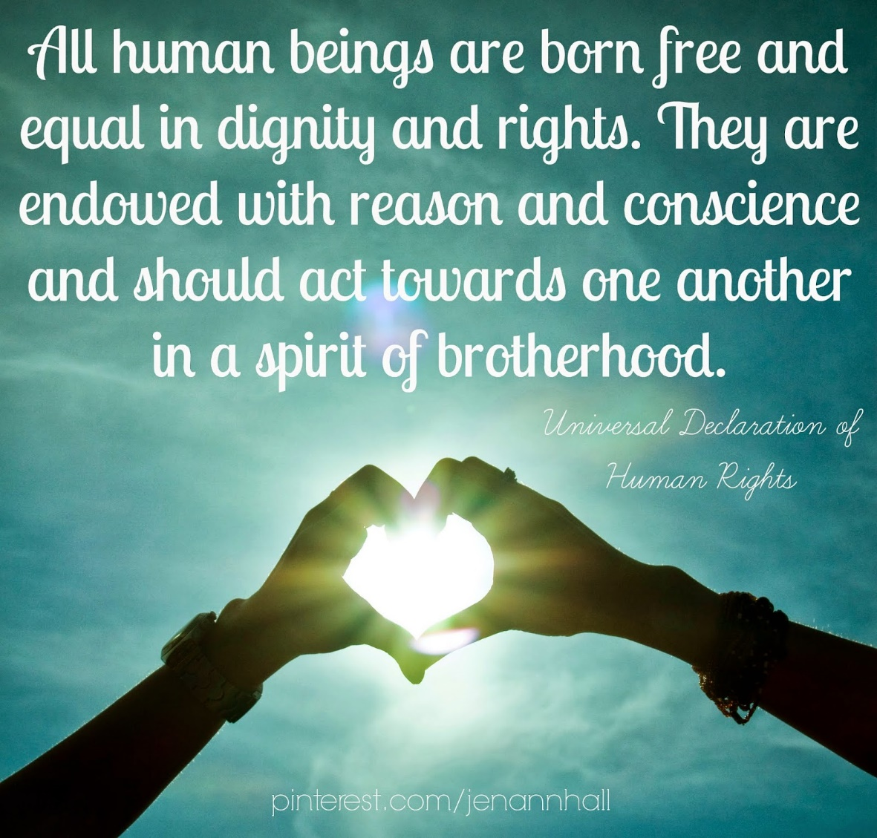

You now have the opportunity to continue to raise awareness by organising a fundraising day/week. All monies raised go directly to the charity WarChild UK, a registered charity specifically focussing on children affected by conflict.
Our aim is for every primary school across the district to do the same!
- We have set up a Just Giving page for schools to use to add their donation. That way, everyone can see how much we have raised collectively.https://www.justgiving.com/fundraising/boy-87-bradford-fundraiser
- We would love to see your fundraising work. Share your work via Twitter @Boy87Bradford as well as your own social media platforms.
You can also contact us at Boy87@rsmps.co.uk and share your ideas.

Class of 2022 – Boy 87 Big Day Out

